

**GROUP ASSIGNMENT (PROPOSED SYSTEM)**

**CT109-3-1 -DGTIN**

**Digital Thinking and Innovation**

**APD1F2011CS(IS)**

|  |  |  |
| --- | --- | --- |
| **DATE ASSIGNED** | **:** | **8TH DECEMBER 2020** |
| **DEADLINE** | **:** | **15TH MARCH 2021** |
| **MODULE CODE** | **:** | **CT109-3-1 -DGTIN** |
| **ASSIGNMENT** | **:** | **GROUP ASSIGNMENT (DOCUMENTATION)** |
| **LECTURER** | **:** | **MS. ROZITA YATI MASRI** |

**Table of Contents: (1920 words)**

Table of figures:.........................................................................................................................3

Acknowledgement......................................................................................................................4

Introduction (100 words)............................................................................................................6

The issues: (84 words)............................................................................................................6

The proposed solution:...............................................................................................................7

The solution: (837 words)......................................................................................................7

The objectives: (67 words)...................................................................................................16

The deliverables: (74 words)................................................................................................16

Flowchart:.............................................................................................................................17 Existing system review: (578 words).......................................................................................22 The review:...........................................................................................................................22

Reviewing G1 Health app....................................................................................................23

Conclusion: (180 words)..........................................................................................................29

Appendices:..............................................................................................................................30

Appendix A: System Manual:.............................................................................................30

..............................................................................................................................................44

Appendix B: Work breakdown structure:.............................................................................44

Appendix C - Terminology:..................................................................................................45 References:...............................................................................................................................46

**Table of figures:**

[Figure 1: Main Entrance of IGMH Hospital (Anees, 2017)......................................................6](https://cloudmails-my.sharepoint.com/personal/tp057768_mail_apu_edu_my/Documents/GROUP%20ASSIGNMENT%20-%20DGTIN.docx#_Toc66553697)

[Figure 2: Aerial View of IGHM Hospital (Anon., 2017)...........................................................6](https://cloudmails-my.sharepoint.com/personal/tp057768_mail_apu_edu_my/Documents/GROUP%20ASSIGNMENT%20-%20DGTIN.docx#_Toc66553698)

[Figure 3: Example Of Federated Login.....................................................................................7](https://cloudmails-my.sharepoint.com/personal/tp057768_mail_apu_edu_my/Documents/GROUP%20ASSIGNMENT%20-%20DGTIN.docx#_Toc66553699)

[Figure 4: ELS computes location (Google, n.d.).......................................................................9](https://cloudmails-my.sharepoint.com/personal/tp057768_mail_apu_edu_my/Documents/GROUP%20ASSIGNMENT%20-%20DGTIN.docx#_Toc66553700)

[Figure 5: Emergency services button.......................................................................................10](https://cloudmails-my.sharepoint.com/personal/tp057768_mail_apu_edu_my/Documents/GROUP%20ASSIGNMENT%20-%20DGTIN.docx#_Toc66553701) [Figure 6: Flowchart to demonstrate providing instructions solution.......................................11](https://cloudmails-my.sharepoint.com/personal/tp057768_mail_apu_edu_my/Documents/GROUP%20ASSIGNMENT%20-%20DGTIN.docx#_Toc66553702) Figure 7: Some Common IoMT Devices (Karaoglu, 2020).....................................................13

Figure 8: Implantable IoMT Devices (Kakade, 2017).............................................................13

Figure 9: Lifestyle monitoring functions of a smart watch (The One Brief, n.d.)...................14

Figure 10: Data sent to servers for AI to process (Ojigbo, 2016)............................................14

Figure 11: IoMT system with cloud and AI integration (Brigadoon Technology, n.d.)...........15

[Figure 12: Smart Pill Box (Elliegrid, n.d.)...............................................................................15](https://cloudmails-my.sharepoint.com/personal/tp057768_mail_apu_edu_my/Documents/GROUP%20ASSIGNMENT%20-%20DGTIN.docx#_Toc66553708)

Figure 13 Emergency services flowchart.................................................................................18

[Figure 14: Registration Flow Chart..........................................................................................18](https://cloudmails-my.sharepoint.com/personal/tp057768_mail_apu_edu_my/Documents/GROUP%20ASSIGNMENT%20-%20DGTIN.docx#_Toc66553710)

Figure 15: Location button for emergency services.................................................................19

Figure 16: Flowchart for IoMT Integration..............................................................................20

[Figure 17: IGMH app registration and login............................................................................21](https://cloudmails-my.sharepoint.com/personal/tp057768_mail_apu_edu_my/Documents/GROUP%20ASSIGNMENT%20-%20DGTIN.docx#_Toc66553713)

[Figure 18: Northwell Health registration page (Anon., 2020).................................................22](https://cloudmails-my.sharepoint.com/personal/tp057768_mail_apu_edu_my/Documents/GROUP%20ASSIGNMENT%20-%20DGTIN.docx#_Toc66553714)

[Figure 19 G1 Health app emergency services (Anon., 2019)..................................................23](https://cloudmails-my.sharepoint.com/personal/tp057768_mail_apu_edu_my/Documents/GROUP%20ASSIGNMENT%20-%20DGTIN.docx#_Toc66553715)

Figure 20: Detect location.......................................................................................................24

Figure 21: Access to the user via GPS.....................................................................................25

[Figure 22:NHSlothian main page for emergency services in website. (Nhslothian, n.d.).......26](https://cloudmails-my.sharepoint.com/personal/tp057768_mail_apu_edu_my/Documents/GROUP%20ASSIGNMENT%20-%20DGTIN.docx#_Toc66553718)

[Figure 23: NHSlothian main page for emergency services in website part 2. (Nhslothian, n.d.)](https://cloudmails-my.sharepoint.com/personal/tp057768_mail_apu_edu_my/Documents/GROUP%20ASSIGNMENT%20-%20DGTIN.docx#_Toc66553719)

[..................................................................................................................................................26](https://cloudmails-my.sharepoint.com/personal/tp057768_mail_apu_edu_my/Documents/GROUP%20ASSIGNMENT%20-%20DGTIN.docx#_Toc66553719)

Figure 24: NHSLothian Emergency Department Royal Infirmary page.................................27

[Figure 25: Vitals measured by Polowatch (Polowatch, 2021).................................................28](https://cloudmails-my.sharepoint.com/personal/tp057768_mail_apu_edu_my/Documents/GROUP%20ASSIGNMENT%20-%20DGTIN.docx#_Toc66553721)

[Figure 26:Disposable Vitls IoMT (Vitls, n.d.)..........................................................................28](https://cloudmails-my.sharepoint.com/personal/tp057768_mail_apu_edu_my/Documents/GROUP%20ASSIGNMENT%20-%20DGTIN.docx#_Toc66553722)

[Figure 27: Smart Pill Box (Elliegrid, n.d.)...............................................................................28](https://cloudmails-my.sharepoint.com/personal/tp057768_mail_apu_edu_my/Documents/GROUP%20ASSIGNMENT%20-%20DGTIN.docx#_Toc66553723)

**Introduction (100 words)**

Himal hospital most commonly referred to as IGMH is the largest medical facility located in Kathmandu the capital city of Nepal. It is situated on the western side of the city. The construction of the hospital was funded by Himalayan trust organization the to signify the friendship between the government. It is dedicated to the Himalayas of the Nepal, which represent the peak of the Nepal. [ CITATION Abo19 \l 1033 ].

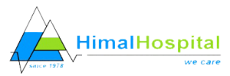

*Figure 1: Front view of the hospital*

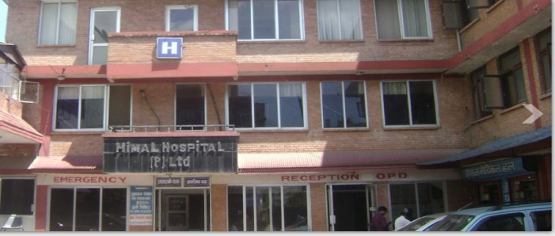

*Figure 2: Logo of the Himal hospital*

The issues: (84 words)

1. Poor user register mechanism which requires users to be physically present at the hospital.
2. Lack of emergency services: no need to log in to get the emergency services, offline services.
3. Lack of location button: (Fast access to user’s location to make the process faster)
4. There is a lack of instructions about how to use emergency services.
5. If a patient experiences a sudden emergency, they are on their own as no medical assistance will arrive until they personally make contact.

**The proposed solution:**

The solution: (837 words)

# Registration Mechanism: (Issue-1)

The most commonly used register mechanism these days are federated login systems and is going to be the proposed system for the application. This would allow users to use a single authentication to obtain access to multiple systems, such as the banking and school systems. This would require a high level of security which would be provided by the user when creating their account by verifying their identity via national identification card number and their phone number. After this the users credentials would be saved on the parent organizations data base. Thus, eliminating the need to login when creating a new session, instead the app sends a one-time authentication request to the user. When authorized the application remembers the user and the device used it registered as a trusted device. This system minimizes security risks and can be integrated with biometrics for further security. In addition, it also enhances user experience by allowing easy access to resources with the least

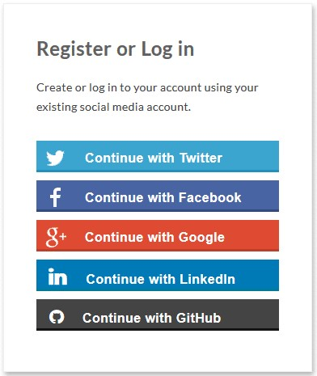

*Figure 3: Example of federated login[ CITATION Raj19 \l*

*1033 ]*

effort[ CITATION Rob19 \l 1033 ].

# Providing emergency services: (Issue- 2)

In an emergency, the top-most priority goes to saving a life. The objective of this proposed solution is to make accident and emergency services accessible to people on the go. Addressing the issues, It has been studied that more than half of the European population could not recall the phone numbers without going through the contacts on their smartphone [ CITATION Jul15 \l 2057 ], and interestingly the app developers of the IGMH app have taken a contrary approach by expecting users to memorize the emergency contact numbers and that is why having a section dedicated to emergency services will emerge as a lifesaving resolution. The hour after an accident is critical and determines the probability of patient survival and therefore, the emergency services will be on main screen of the app. The users will be given two options to choose from, the first one being for accidents and the second one being for a medical emergency. If it is a medical emergency, then the user will be asked to specify the health department, so the hospital can plan the treatment in advance.

Besides this, with our solution, the app will store the contacts of the patient’s family and friends with the same blood group. Therefore, in the event of an accident, as the emergency button is pressed the contacts will be notified and can donate blood if required.

# Location button for Emergency services: (Issue-3)

It is possible to develop a solution for the patient to reach the rescue solution as soon as possible, such as locating him by pressing one button, when the patient is unable to locate or if there is a problem, this can be solved by entering his data and determining his location**. [ CITATION her21 \l 1033 ].** Significantly, once this is implemented in the app, a tool can be developed to connect user, customer service, and the hospital together.

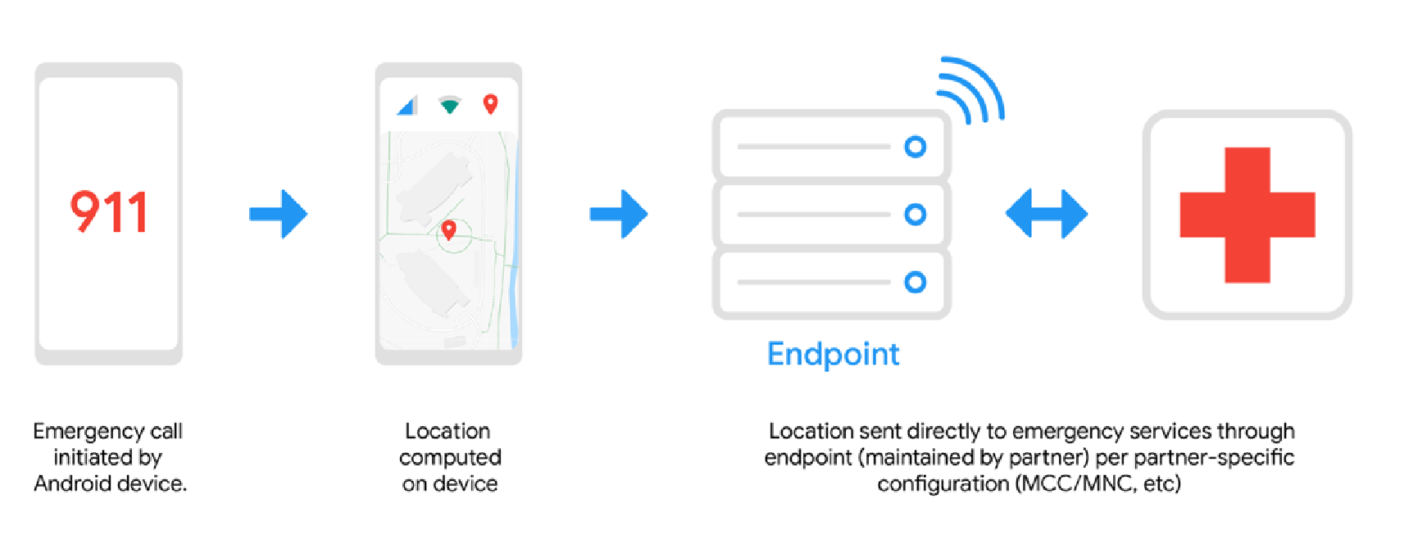

*Figure 4: ELS computes location[CITATION Goo212 \l 1033 ]*

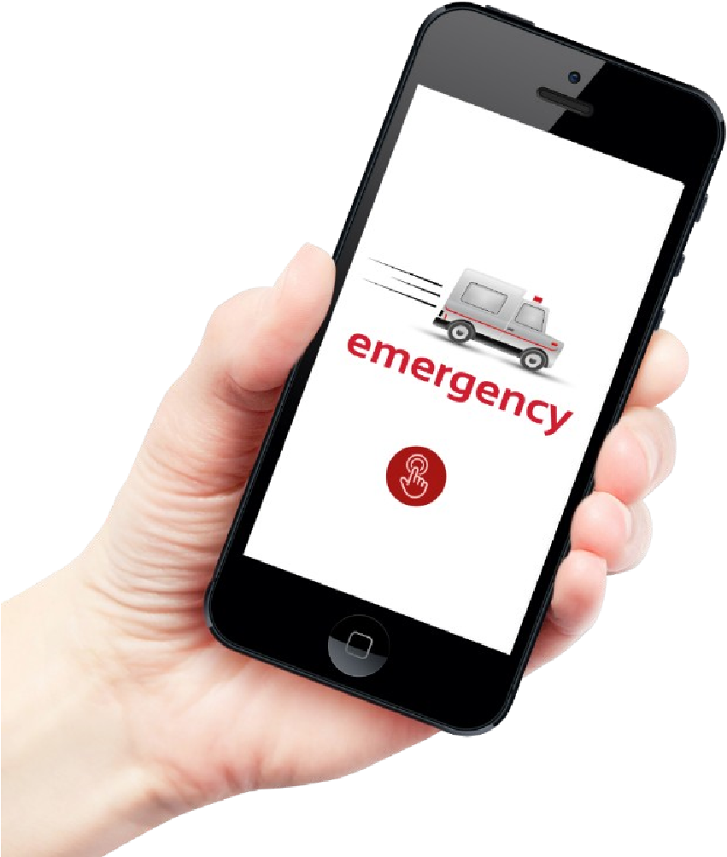

*Figure*

*6*

*:*

*Emergency services button*

An example of the same similar features is the ELS service on Android, which has the ability to rescue a patient at full speed by controlling their location and facilitating their timely access to an ambulance.

This system can be used by satellite or Wi-Fi and is characterized by great accuracy in locating places, and one of its most important advantages is that it locates the place in the fastest time and will not take much time in procedures or identification, it can be up to the patient to receive the data before calling.

The patient can press the button to determine where the ambulance arrives at the specified location, and the user can also be allowed in the options in the application to add an accurate address while determining the position, The user

can write the patient information that will give the patient their priority in obtaining the ambulance service and communicate in the event that the specified location is not reached, after that the hospital takes the necessary measures to send the ambulance, but this is according to their case if the matter is dangerous the ambulance rushes to reach the exact location, and priority is given to the most serious cases.

Asia Pacific University of Technology and Innovation

9

What is an

emergency?

What to do in

case of

emergency

Not an

emergency

*Figure*

*7*

*:*

*Flowchart to demonstrate providing instructions solution*

# Provide instructions: (Issue-4)

Due to the lack of directions, it will be crucial to add some guidance to help the users in any case scenario.

CT109-3-1-DGTIN Digital Thinking and Innovation Group assignment What to do if Alternatives anything went to emergency Need help? wrong services

# The service What it offers

**What is an** In this part of the service, the system will provide clear guidelines **emergency?** for the user to be able to differentiate between emergency cases and other cases. To ensure that users of different age groups understand and find it easy to use the emergency services, the system will be clear and straight-forward.

**What to do in case of** If it is the case that the patient has an emergency, the system will **emergency** offer instructions on what to do to get the emergency services.

This will include how to contact the hospital.

**Not an emergency** Sometimes patients are not fully aware of what cases are considered emergencies, meaning the cases could be treated on other departments instead of the emergency department. Accordingly, the system will clarify to the user that their case is not considered an emergency.

**What to do if** When trying to contact the hospital and somehow failed, and if **anything went wrong** there were any issues when trying to get the emergency services, the system will provide directions to the users. This is to ensure that nothing goes wrong.

**Alternatives to** If the users are not able to get the emergency services for any **emergency services** reason, the system will suggest different alternatives. If there are no ambulances available, the user should be warned and given suggestions on what to do. If the case of the emergency will get worse with time, the system can suggest that the patient should ask for medical assistance to stabilise the situation.

**Need help?** Even if the situation is not an emergency, it is not right to leave the patients in the dark. Therefore, the system will guide the user on what to do if they needed any help regarding other cases that are not emergencies.

## IoMT Integration: (Issue-5)

Add a new tab under the name 'Remote Care' where patients register their portable medical devices.

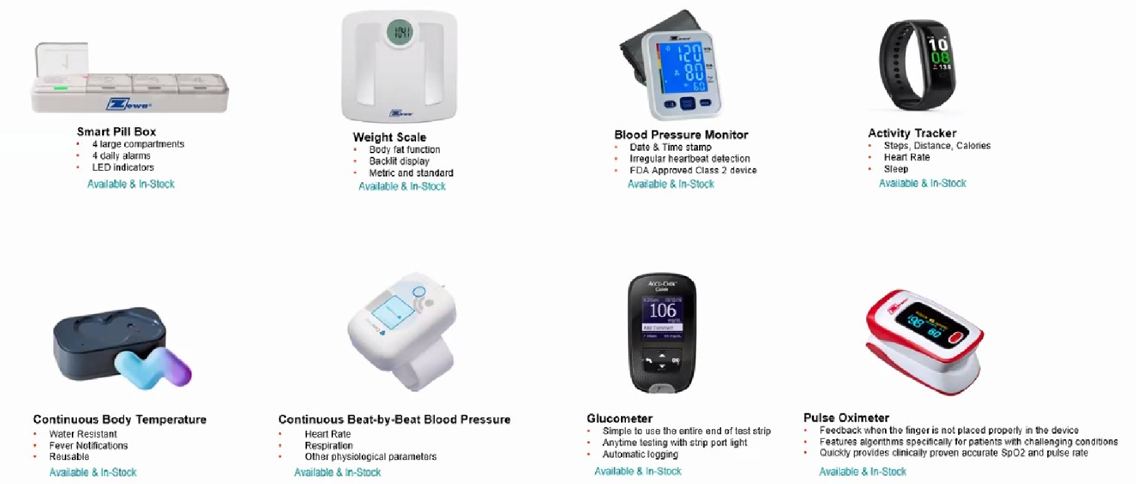

*Figure 8: Some Common IoMT Devices [ CITATION Kri20 \l 1033 ]*

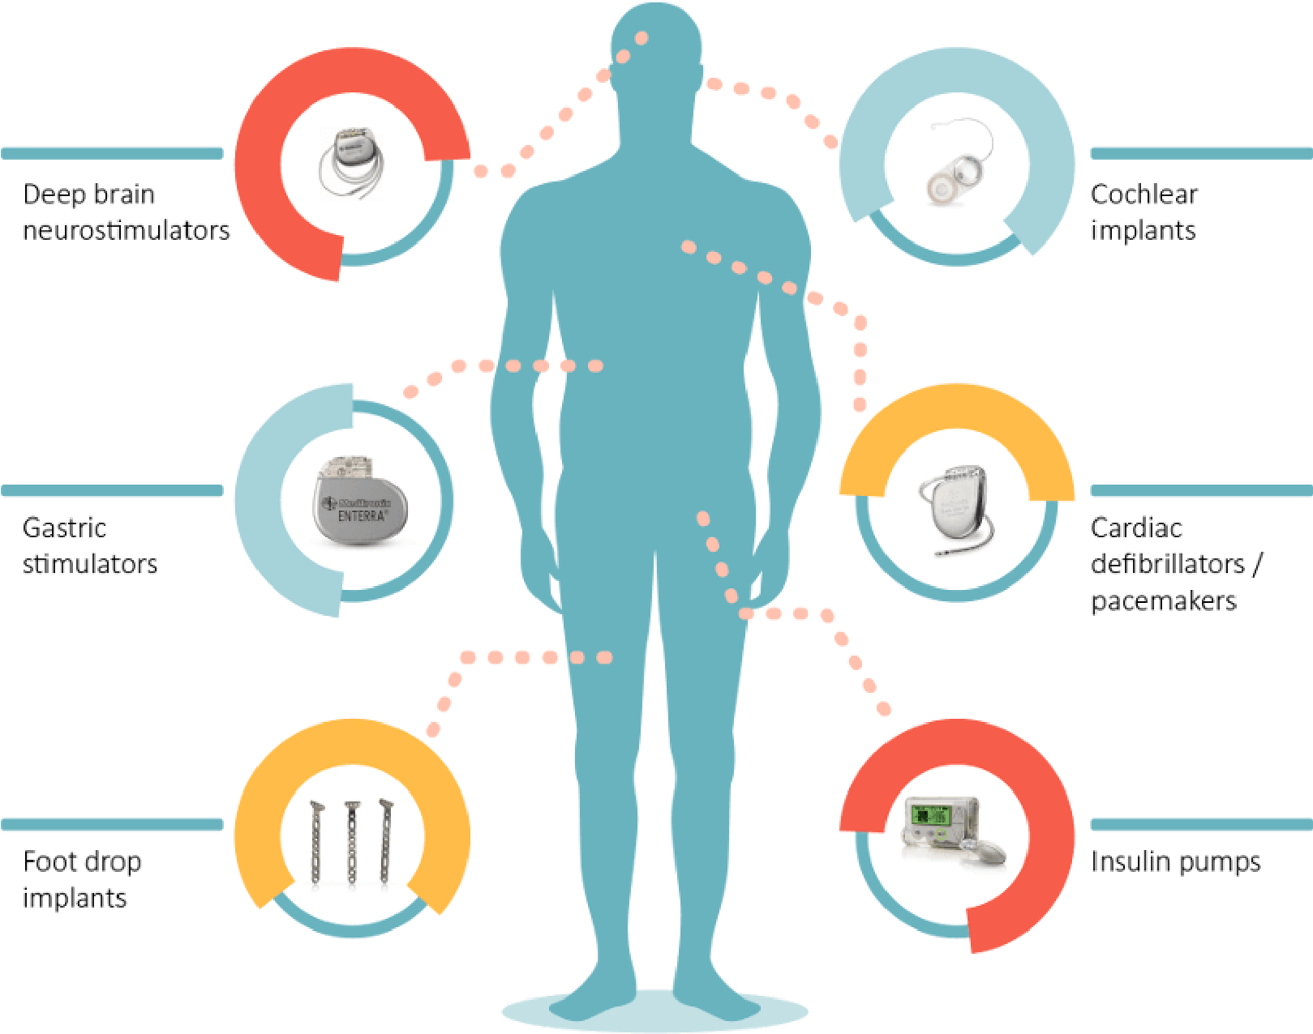

*Figure 9: Implantable IoMT Devices [ CITATION Nam17 \l 1033 ]*

Health data can also be collected and synced by non-medical devices such as smart watches and synced.

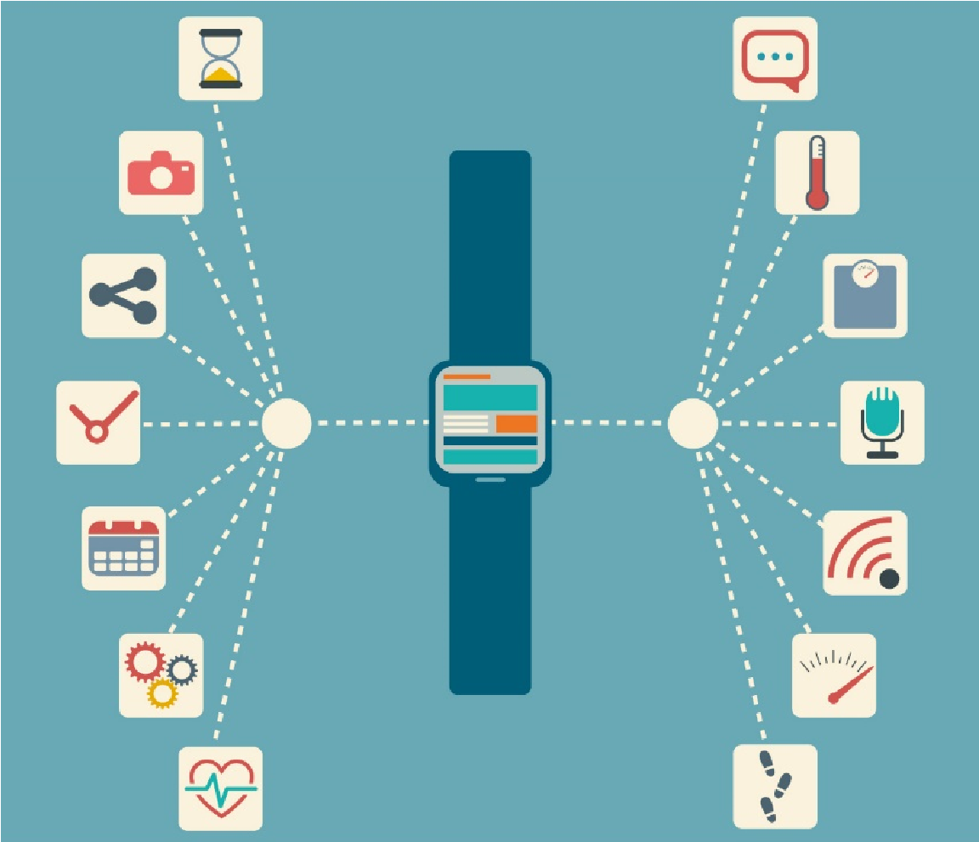

*Figure 10: Lifestyle monitoring functions of a smart watch [ CITATION The21 \l 1033 ]*

The collected data is sent to the servers of the hospital. If it detects abnormality, the concerned doctor is informed and given statistics regarding the patient.

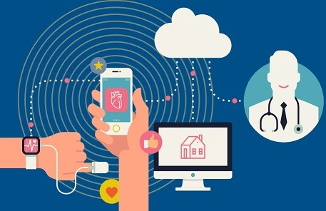

*Figure 11: Data sent to servers for AI to process [ CITATION Sol16 \l 1033 ]*

It is then at the discretion of the doctor to either contact the patient or send an ambulance to the patient’s location.

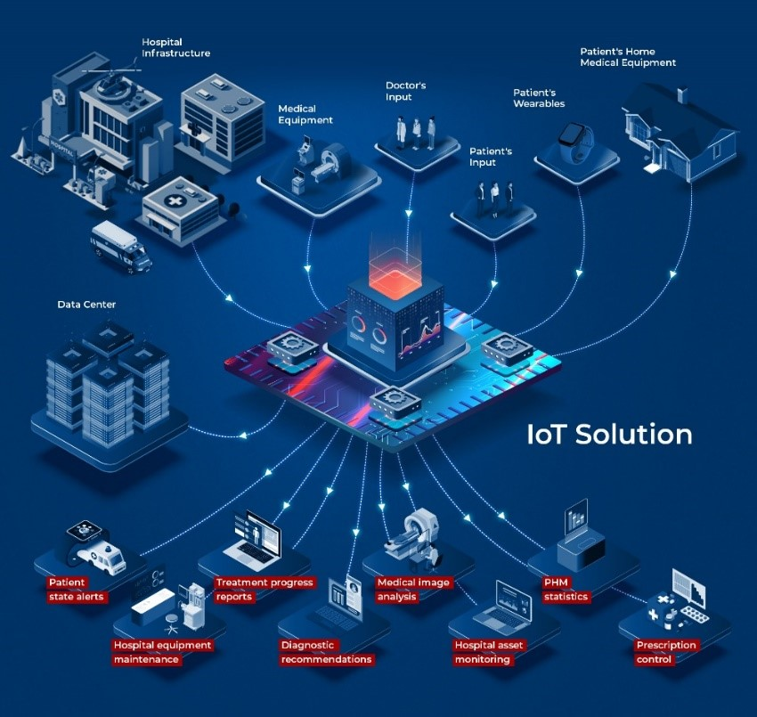

*Figure 12: IoMT system with cloud and AI integration [ CITATION Bri21 \l 1033 ]*

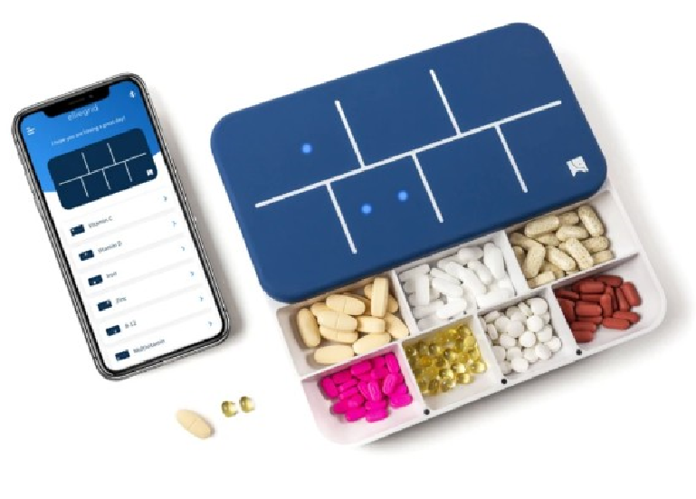Some patients may be on maintenance drugs which requires constant dosage tracking. Two examples of such conditions include Alzheimer’s and Depression. Having a 'Medication Tracker' would ensure patients regularly take required dosages and any missed dosages are recorded.

If the system detects a patient exceeding the threshold of missing dosages, the doctor is immediately informed.

*Figure 13: Smart Pill Box [CITATION*

*Ell21 \l 1033 ]*

The objectives: (67 words)

* To make it easier for the patient to get A & E services
* To save lives and help those in need by making the service more accessible.
* To create a user-friendly interface for all age groups • To remove the need to use internet / mobile data.
* To add an expert system (AI)
* To remotely monitor patients and automatically call ambulance services to their location when need be.

The deliverables: (74 words)

1. A secure way to create an account through the app and verify the user's information.
2. Quicker access to emergency services
3. Fast access to user’s location to make the process faster/ save lives.
4. In case of confusion users will be able to find out what to do
5. Geriatric or patients with chronic illnesses will now have ambulances at their location without needing any communication with any emergency service or hospital.

Flowchart:

Figure 13 demonstrates the general flowchart that showcases how all the different aspects of the proposed solution are connected.

Starting from the first encounter after opening the app from the user’s side. The first tab the user will see will be the emergency services tab. From there the user will be taken through a process in which they will have to provide their location and emergency type, while reading through guidelines.

Part of providing the emergency services proposed solution is the functionalities of remote control, which cannot be accessed until the user verifies themselves. These can be accessed once the user presses the account tab.

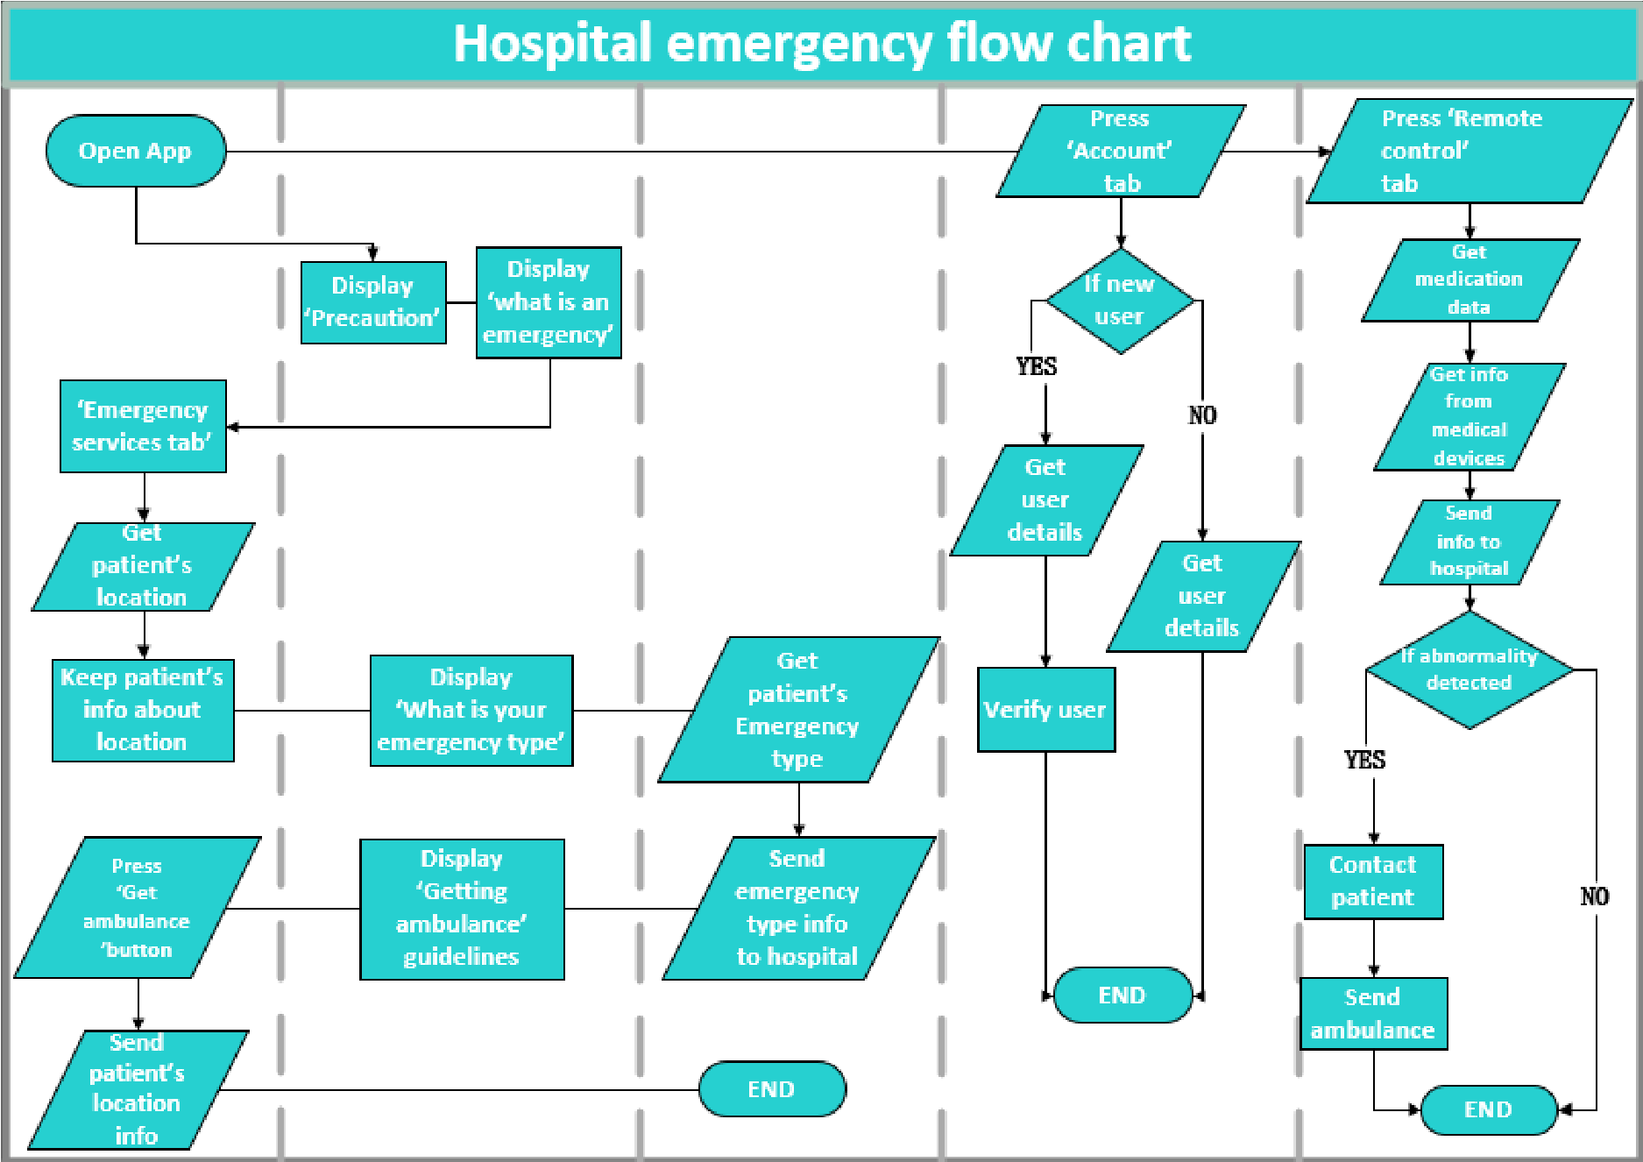

*Figure 14: The general flowchart of the proposed system*

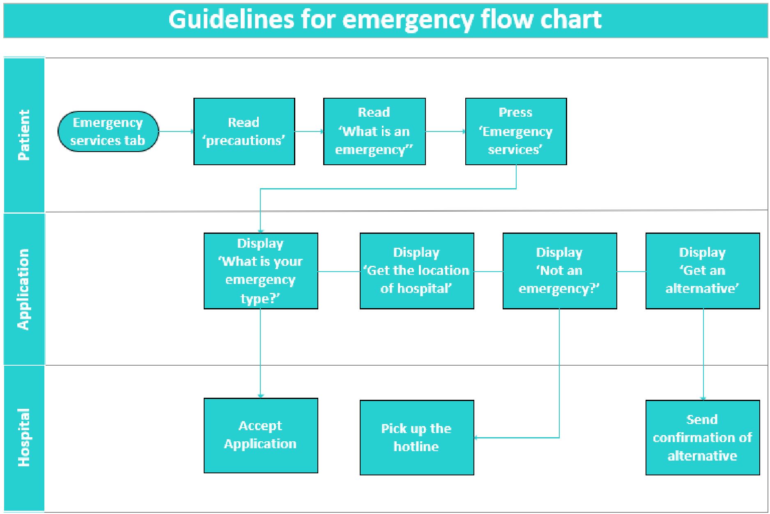

*Figure 15: Location button for emergency services*

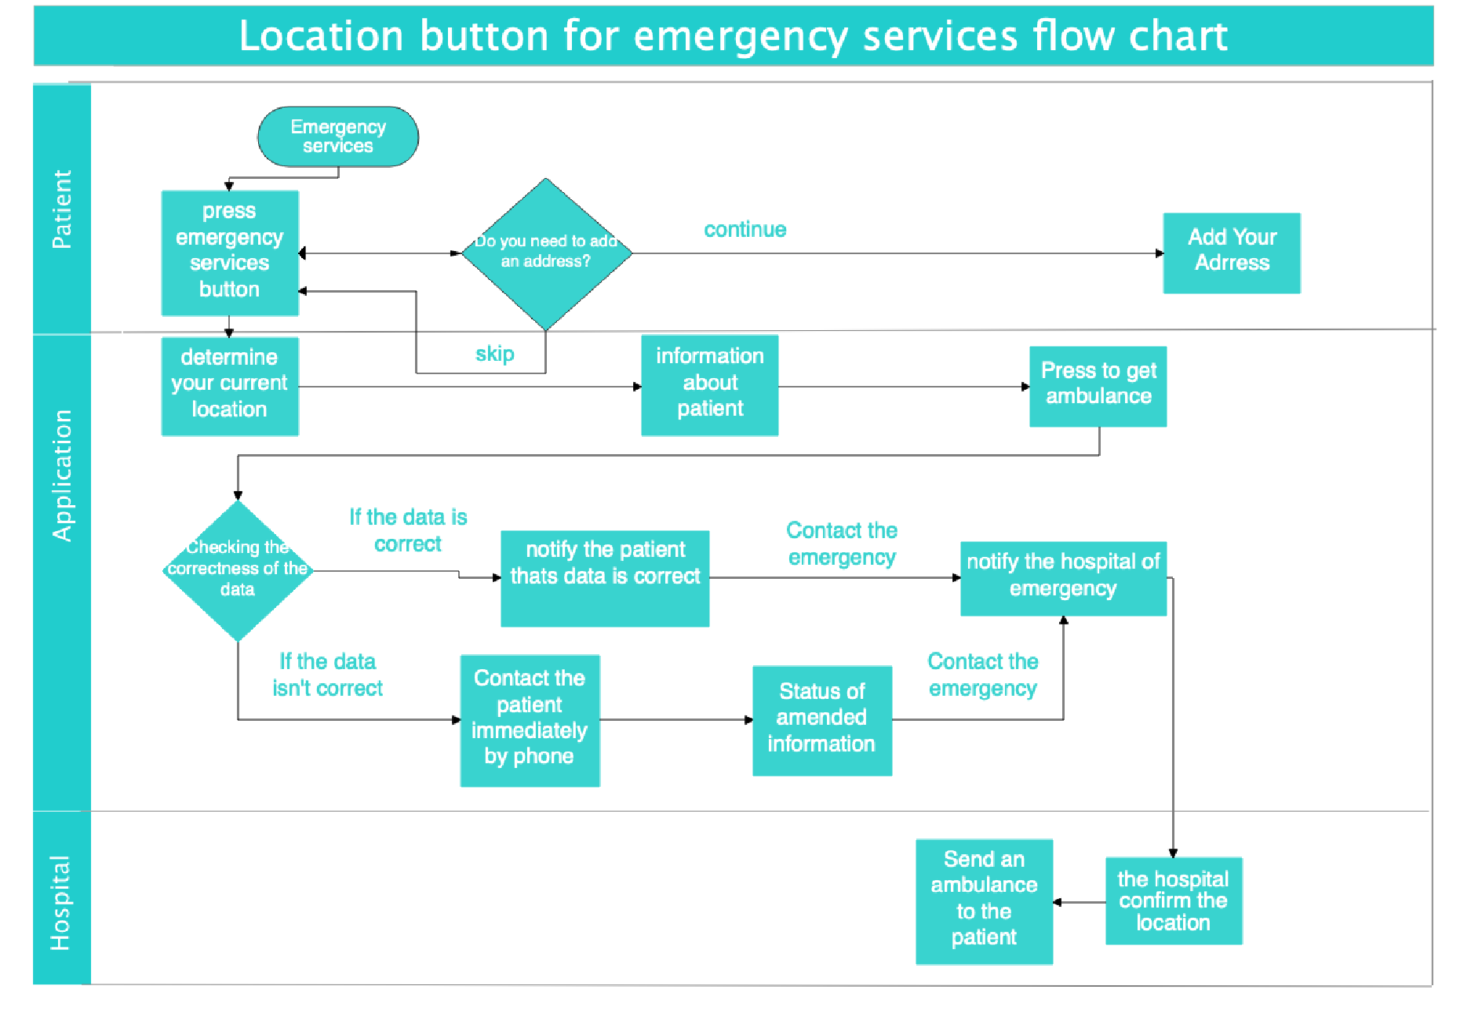

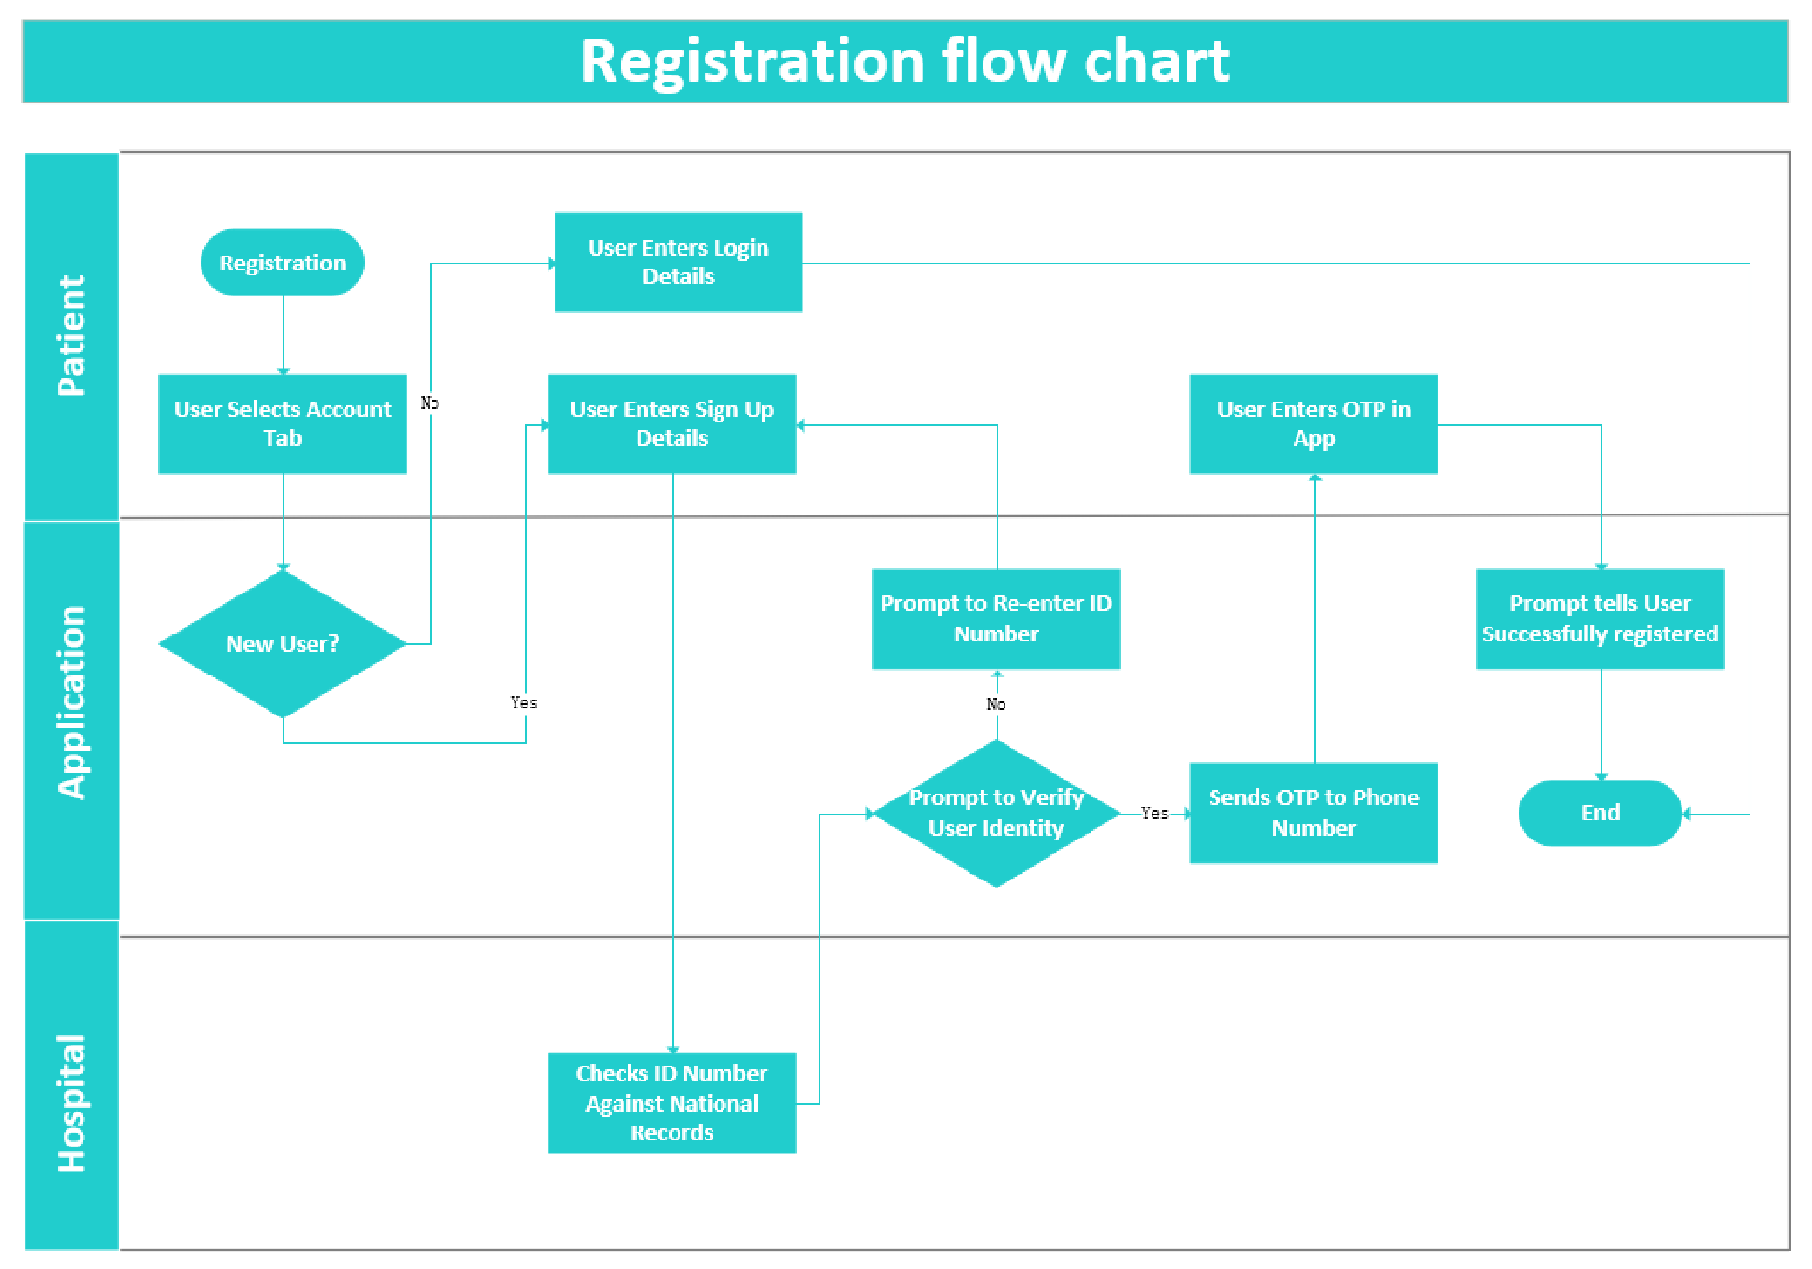

*Figure 16: Flowchart for IoMT Integration into the Hospital Application*

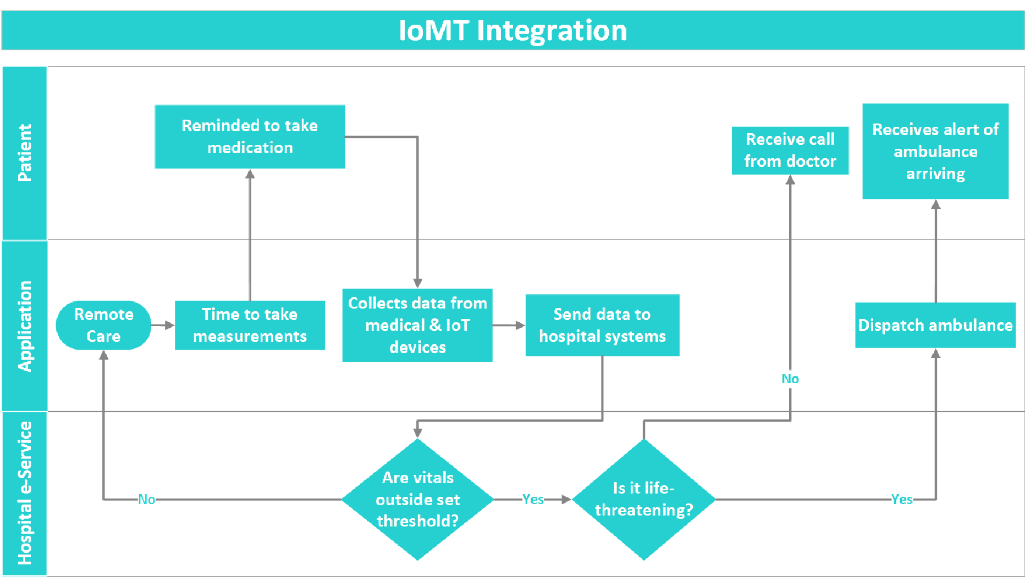

*Figure 17: Flowchart for IoMT Integration*

**Existing system review: (578 words)**

The review:

## Reviewing Northwell Health’s Patient Portal: (Issue 1)

*Figure 18: IGMH app registration and login*

Northwell Health’s registration allows users to easily and securely create an account and

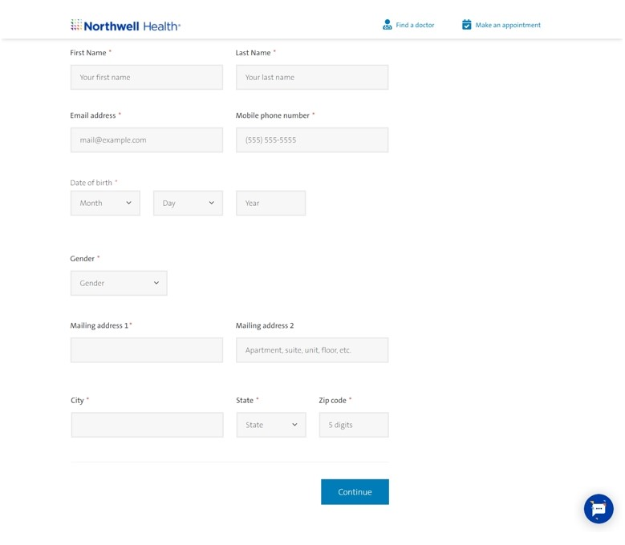

*Figure 19: Northwell Health registration page[ CITATION Nor20 \l 1033 ]*

verify their identity through their personal mobile phone number. The figure below shows the registration page for Northwell Health.

The proposed system will have a similar system implemented which will allow users to verify their identity securely.

## Existing system review: (Issue 2)

Reviewing G1 Health app.

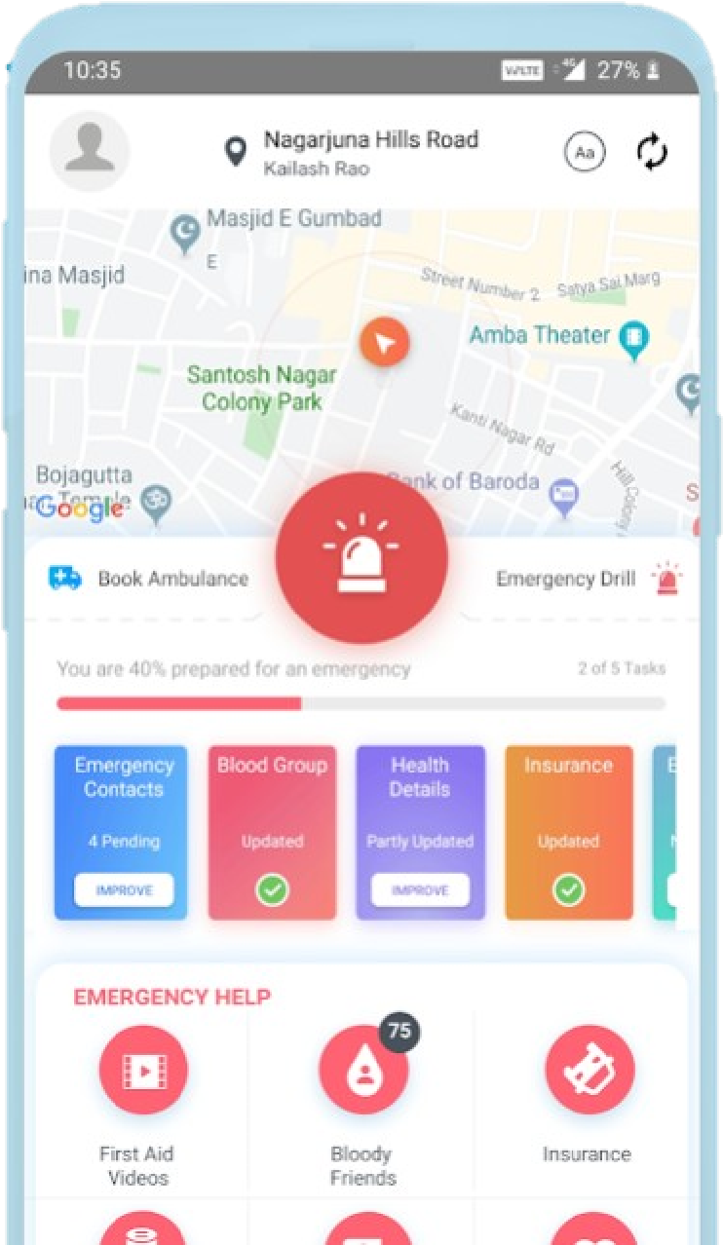The current IGMH app unquestionably fails to address some of the key issues of our time, it has fallen behind in keeping up with the technology. The app misses out on having an emergency section and solely relies on utilizing traditional ways when it comes to an emergency. Talking about digitalization, a system for healthcare and specifically has been developed which primarily aims to reduce the casualties during an accident. The system involves having an emergency button on the main screen which shares the patient’s location with 108 hospitals and notifies the nearest responder in range to do the first aid of the patients as the ambulance arrives. The app also notifies the friends and family of the patient, ambulance department and the on-duty doctor at the destination hospital. The destination hospital will be given access to the patient’s health records which will help the hospital in preparing the treatment in advance. Moreover, the app features a live video consultation for patients

*Figure 20 G1 Health app emergency services [ CITATION G1H191 \l 1033 ]* who are unable to travel in case of a medical

emergency. [ CITATION G1H191 \l 1033 ]

**Conclusion**: The app utilizes technology to ensure causalities are minimized. The features this service uses will be introduced in our proposed solution, such has having an emergency button the main screen of the app, storing the contacts of family and friends with similar blood group and notifies them in case of an emergency.

## Emergency plus app system review: (Issue 3)

In the emergency plus application, the time and location are the basis of the idea of the program’s work and how the location is linked to the person via satellites, all in just a few moments and the application includes the ability to access the police and emergency services by determining the location, and that is when the user opens the application for the first time.

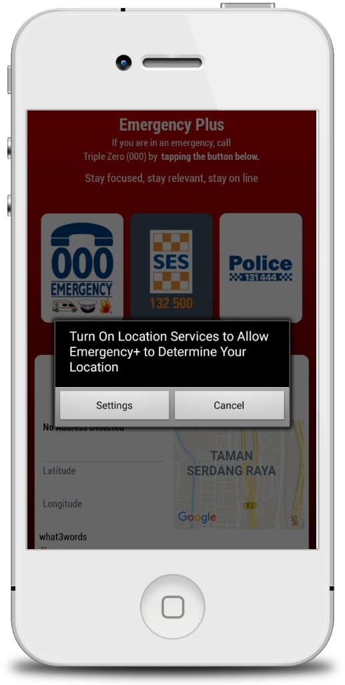

*Figure 21: Detect location*

It is possible through the site to contact the police or ambulance after determining the location, and the user's rescue rate is very high because once the user calls an ambulance or the police, the location of the user number has been saved by the hospital or police department, and this means that the matter will not take a long time until the address is known, then the aid is sent immediately. [ CITATION Goo213 \l 1033 ]

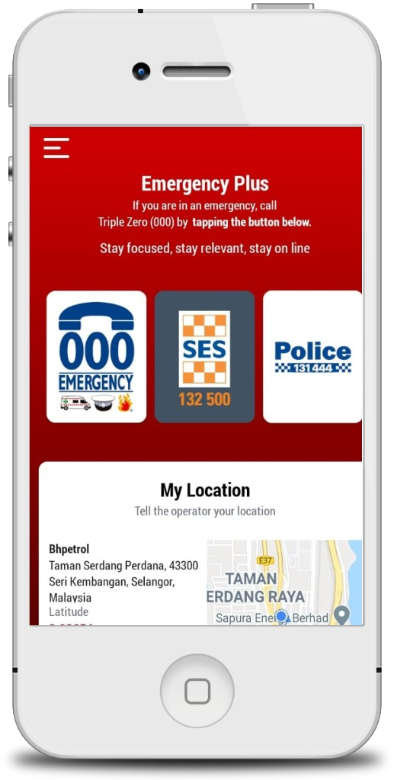

*Figure 22: Access to the user via GPS*

**Conclusion**:

The emergency application gives the user to locate him as soon as possible by opening the application and then calling the ambulance number, and you will come to the specified place directly and this is an example of the third solution in the proposed solutions about how to locate a person and how to reach with just a click of a button.

## NHSlothian system review: (Issue 4)

Reviewing the NHSlothian: Guidelines in website

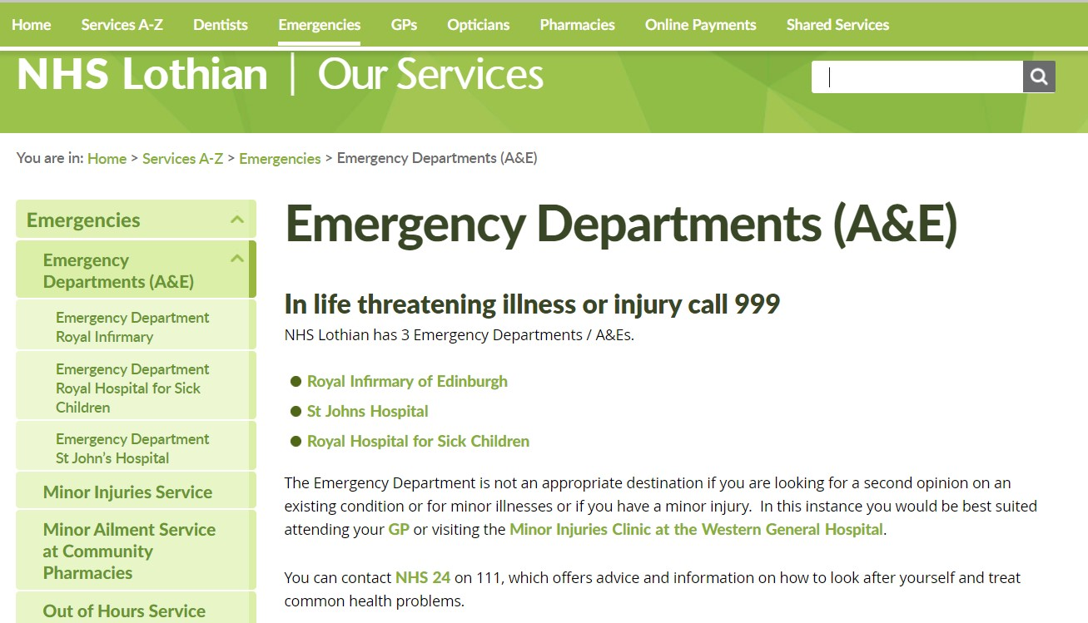

*Figure 23:NHSlothian main page for emergency services in website. [ CITATION Nhs20 \l 2057 ]*

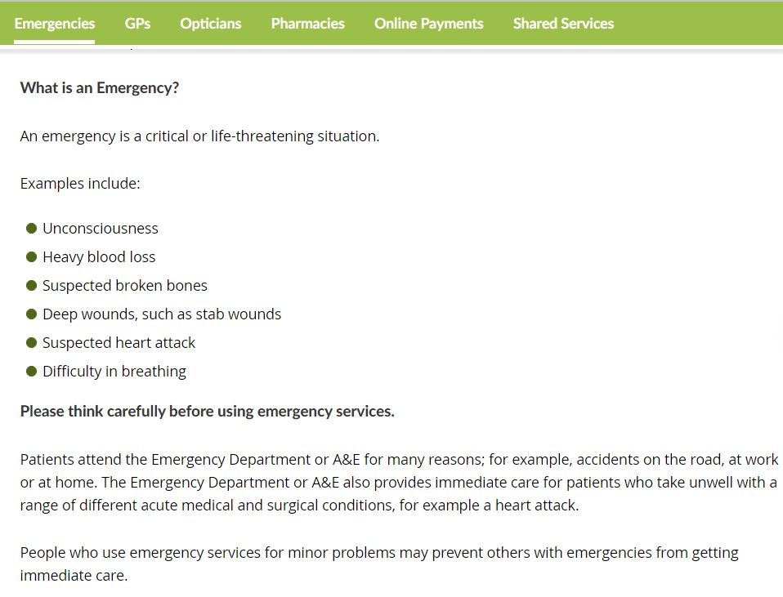

*Figure 24: NHSlothian main page for emergency services in website part 2. [ CITATION Nhs20 \l*

*2057 ]*

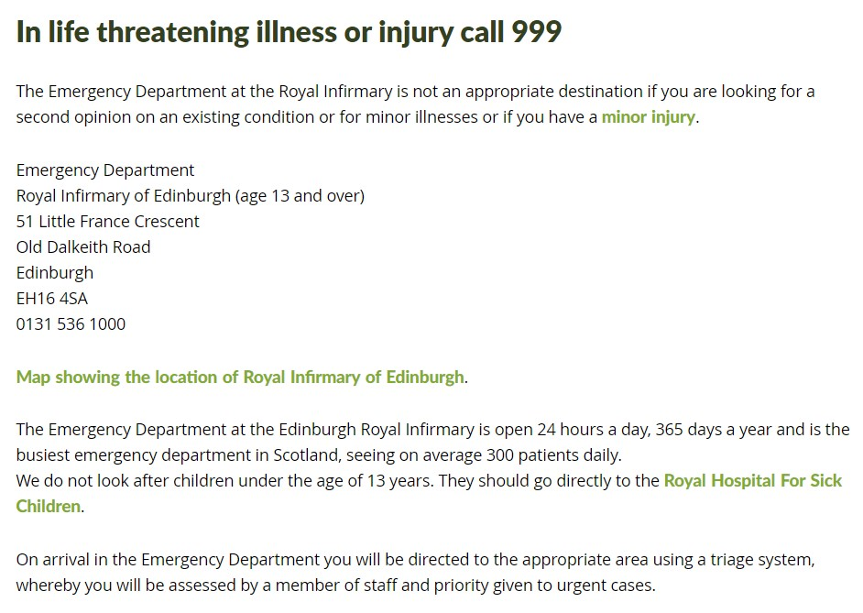

*Figure 25: NHSLothian Emergency Department Royal Infirmary page*

What is an In the website, it is clearly pointing out which cases are considered emergency emergency? If the cases are life-threating they need to contact 999 not the emergency department

Locations and The website provides the location of the emergency departments Contact Users will be able to contact the hospital if needed

Guidelines and There are clear guidelines to let the user know what to do even if their case is not an emergency precautions It is clearly stated that it is a serious matter, and user should not misuse the emergency services



## Conclusion

Available IoMT Services:

**Vitls:**

This organization has developed a disposable device that is to be attached to all patients that enter an ED. The astonishing feature of this organization is that their device offers – “earlydetection of deterioration” which means that patients are diagnosed before any serious symptoms rise [ CITATION Lin21 \l 1033 ]. This decreases the length of stay, treatment costs, and re-admissions to the hospital.

The early detection feature can immediately bring any upcoming chronic issue to the doctor’s attention allowing them to call the ambulance to and treat the patient before the onset of any serious health risks. This function will increase efficiency of the whole solution.

**Elliegrid:**

Elliegrid is a smart pill box that reminds the patients what medication and how many to take. The user must, however, manually add all the medications that they need to take and organize the compartments themselves. Neither data is neither collected by the box, nor the app which deems it unsuitable for an advance IoT system.

Having medication tracking will give doctors insight of the patient’s consistency of dosages. If the medication is such that missing too many dosages can cause serious issues, then the doctor can send an ambulance to the patient and carry out any medical procedures necessary before the situation worsens. Medication tracking in the application can decrease the susceptibility of the patient forgetting their medication.

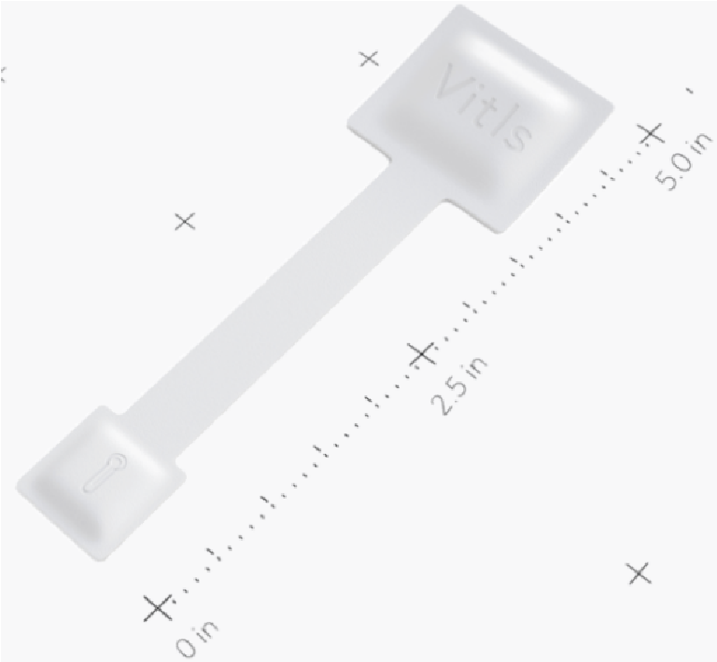

*Figure 26:Disposable Vitls IoMT*

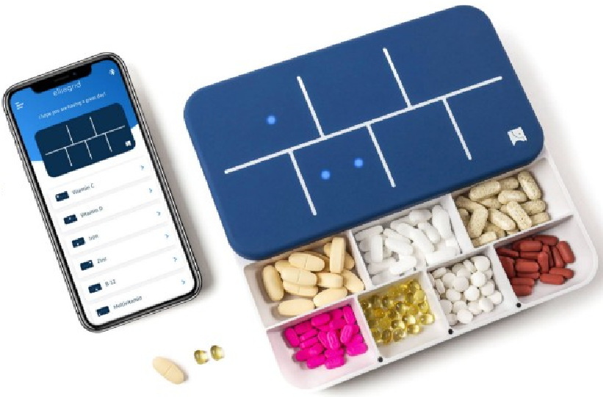

*Figure 27: Smart Pill Box [CITATION Ell21*

**Conclusion: (180 words)**

In summary, after applied many of service in the application, such as the biometric system, to ensure the identity of the user and prevent fraudsters from disturbing the hospital and that the application is equipped with an Immediate emergency service, to the rescue at the perfect time, so adding instructions to guide the patient be provided with an emergency number, the division of departments to make a place for emergencies and otherwise, correct the errors of communication failure and errors of users and precisely direct them and Providing assistance and guidance for cases of less danger, just like an emergency and updating the login system and safety standards in the application, adding features on the website and application that helps patients to reach the most degree of safety and protection and provide medical care for them, and add instructions to the patient to facilitate everything that can be known about the application and how to access solutions that help him in the fastest possible thing and the knowledge about usage and all of this falls under the degrees of safety.

**Appendices:**

Appendix A: System Manual:

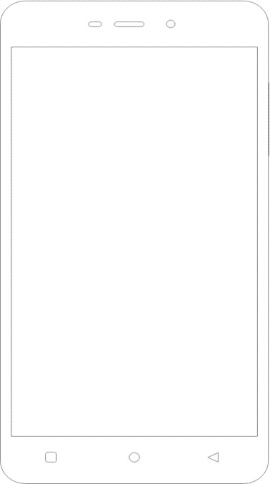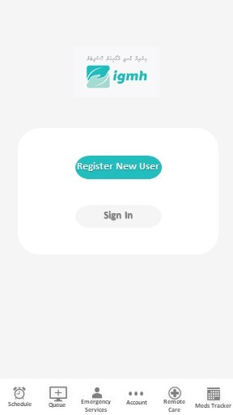

Solution One Wireframe:

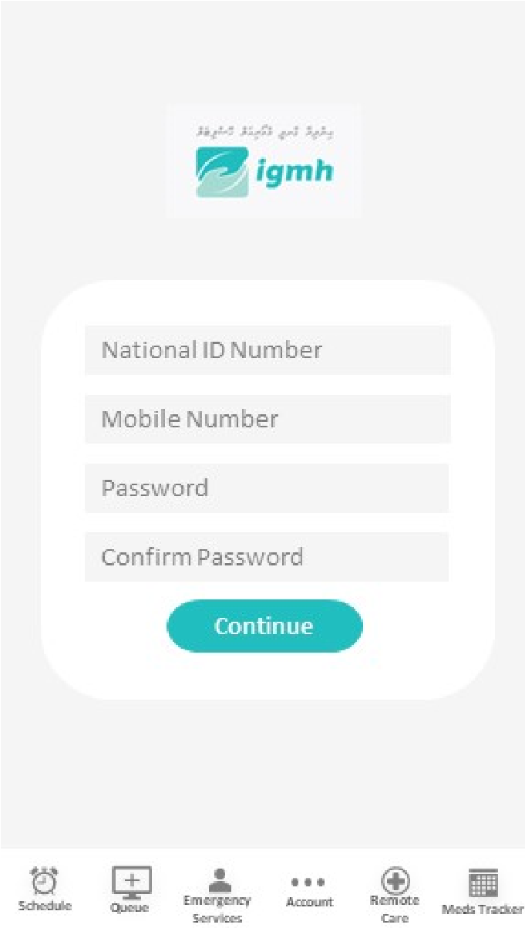

After the user presses

the Register button

he/she is prompted to

enter user details

First screen when the

account tab is

selected

First screen when the

Once the user details are submitted the ID is checked against records to verify identity

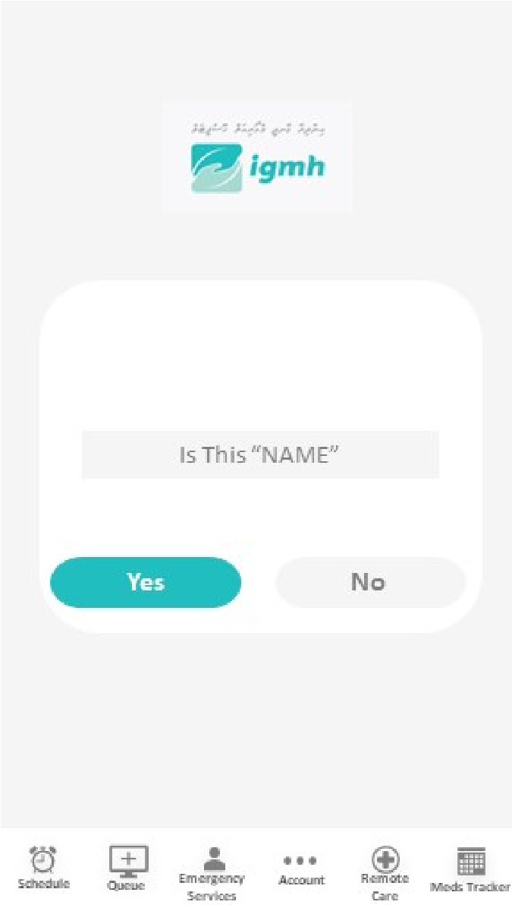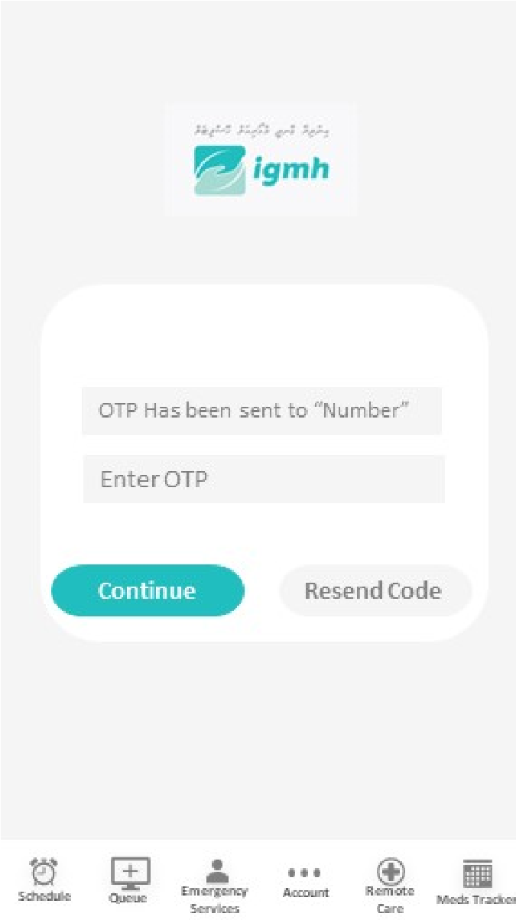

An OTP is sent to the users phone number for further verification and prompts to enter

OTP

Once OTP is entered the APP notifies user that registration was successful

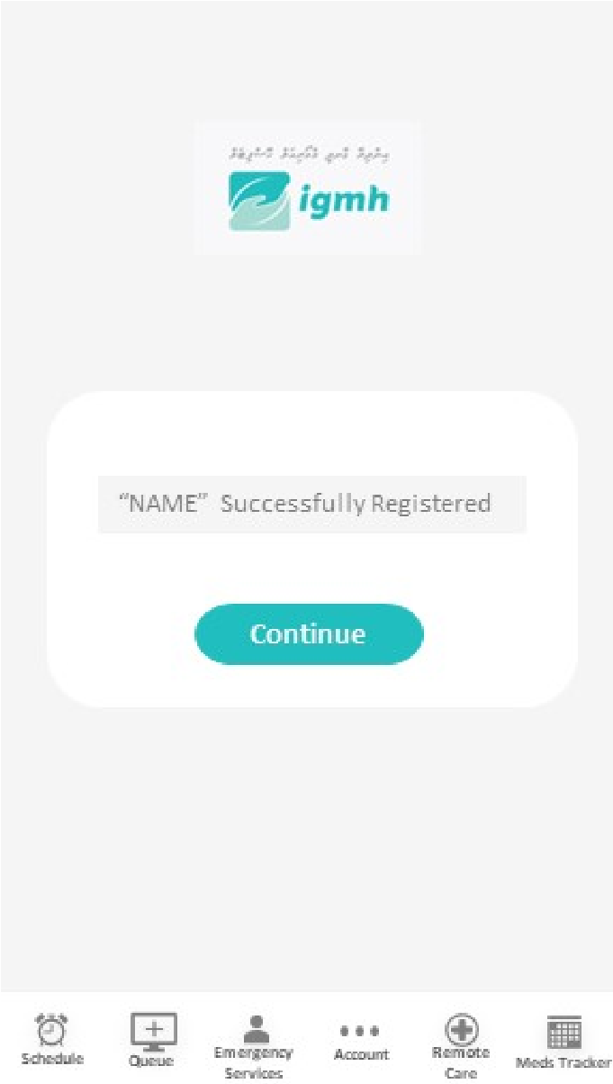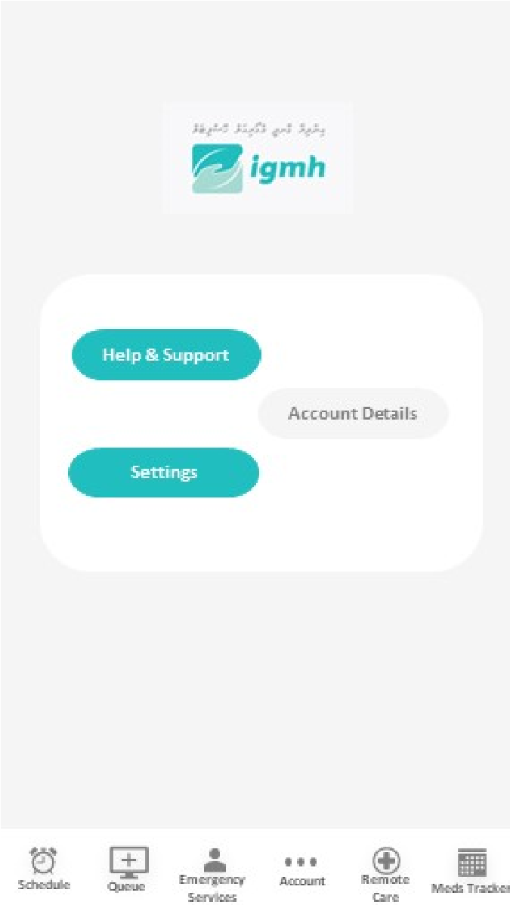

Functions available in account tab after logged into APP

Functions available in

CT109-3-1-DGTIN

Digital Thinking and Innovation

Group assignmen

t

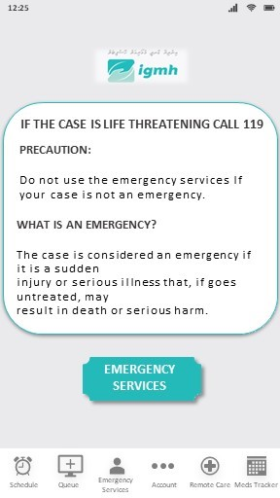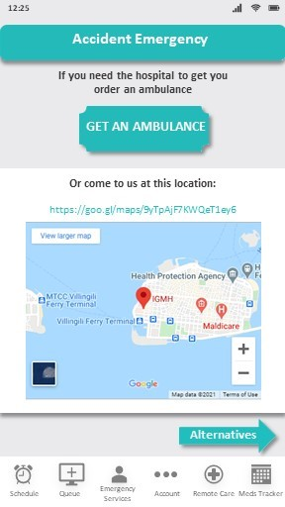

This is the first page the user

will see after opening the

app. This is the ‘emergency

services’ tab

The user needs to press the

emergency services button to

access the emergency

services

This is the first page the user

After the user presses the

‘Accident Emergency’ button,

this page comes next.

Here the user can click the

‘Get an ambulance’ button to

send their location to the

hospital.

CT109-3-1-DGTIN

Digital Thinking and Innovation

Group assignmen

t

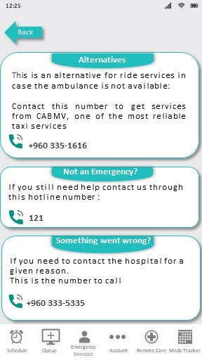

This is the Alternative page,

which can be accessed after

pressing the ‘Alternatives’

button in the ‘Accident

Emergency’ page.

This page provides the user

with ways to deal with the

different situations they are

**in**

CT109-3-1-DGTIN Digital Thinking and Innovation Group assignment

Solution Three Wireframe:

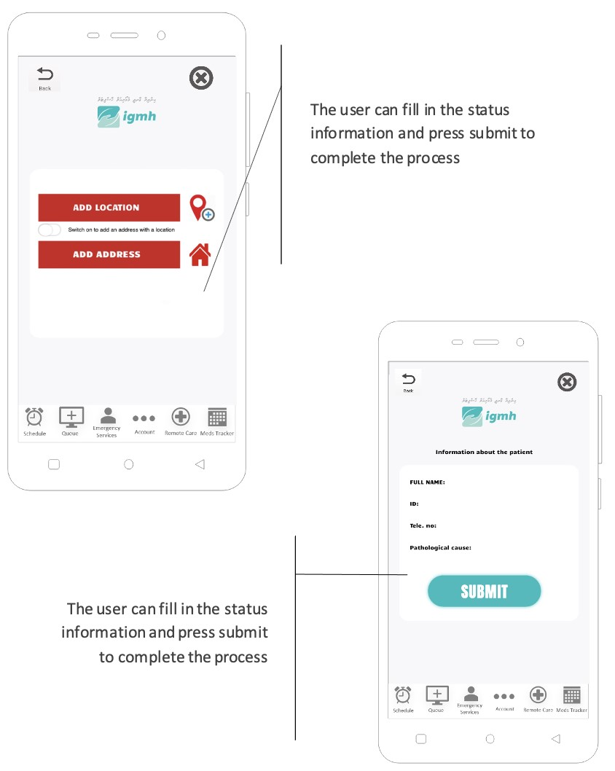

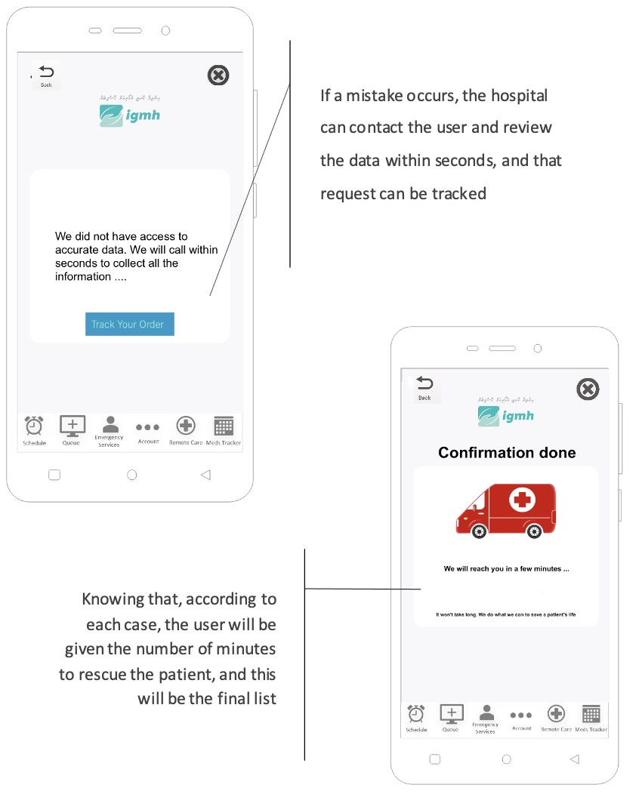

CT109-3-1-DGTIN

Digital Thinking and Innovation

Group assignmen

t

Solution 4 Wireframe:

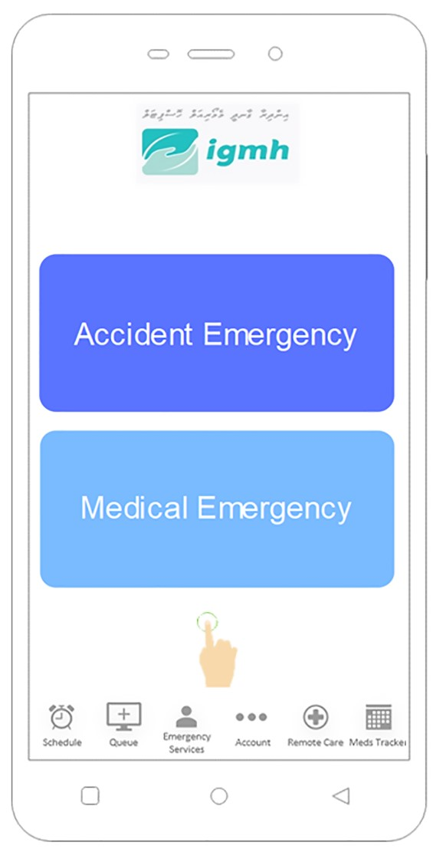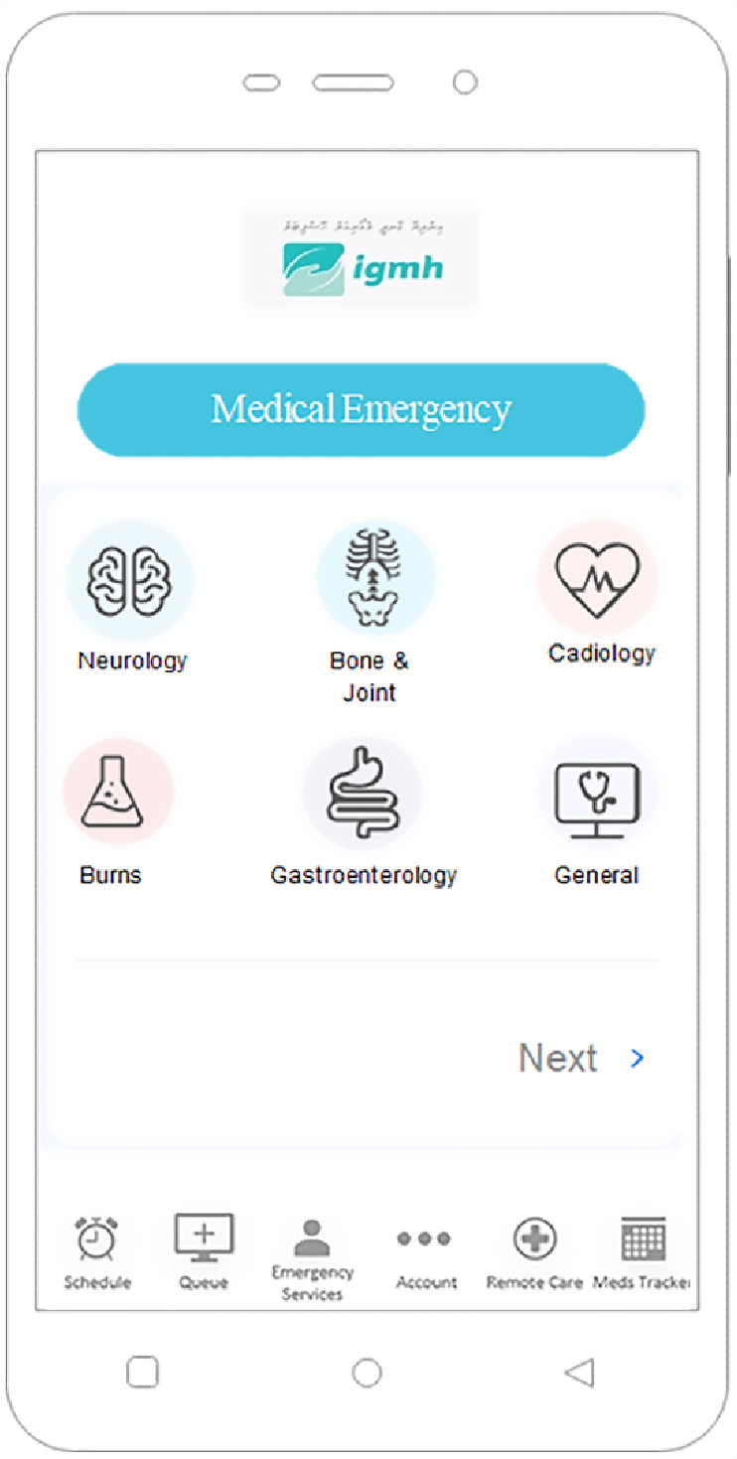

If it is a medical

emergency, patient will be

asked to select the health

department.

Biometric Authentication

Solution Five Wireframe:

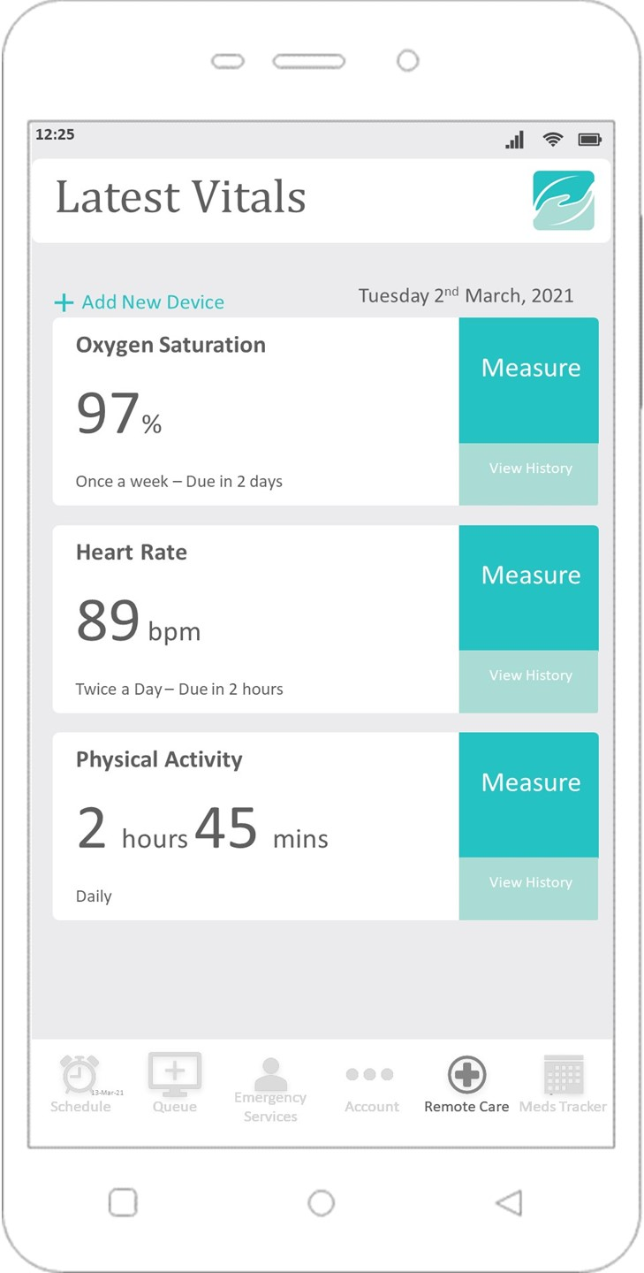

Clicking on this tab opens

the current remote care

tab.

‘View History’ pulls up a

chart that statistically

displays all the previous

readings taken.

Each ‘block’ gives details

and options regarding the

respective readings. At

the bottom of the blocks,

the frequency of the

reading and the time left

for the next reading can

be seen.

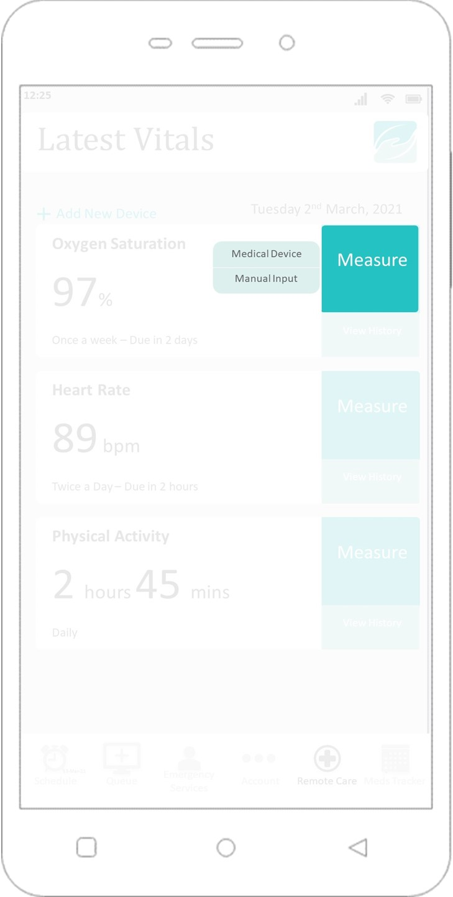

Upon clicking measure,

the user can either select

the first option to take

readings from the medical

devices provided or the

second option to input

readings manually

themselves.

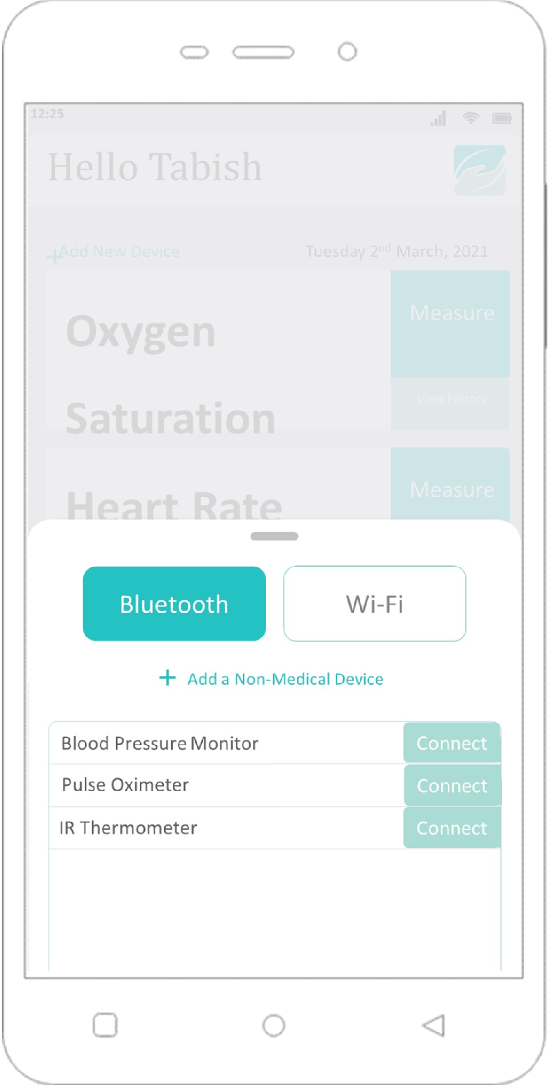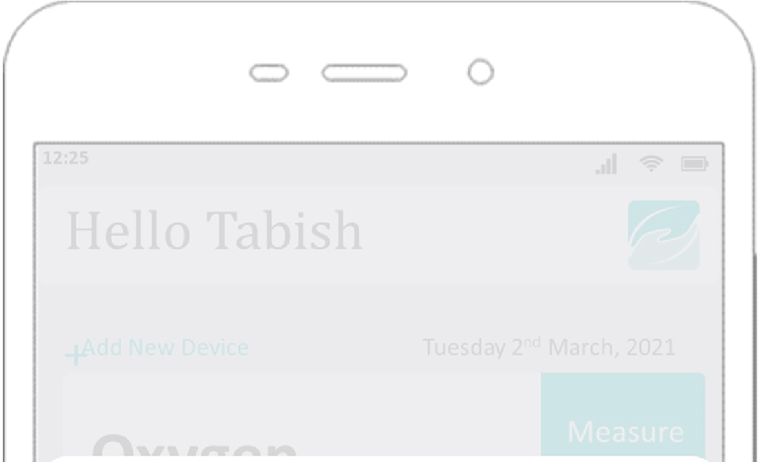

To connect to a non-

medical device such as a

smart watch, select this

option. A similar pairing

process will take place.

Available IoMT are

displayed in this menu.

Upon tapping the

‘Connect’ option, pairing

is requested to the

respective device

.

Tapping ‘Add New Device’

pulls this menu up from

the bottom. Either

Bluetooth, or Wi-Fi can be

selected to connect to

IoMT that are set to

pairing mode.

This option registers a

portable medical device

that the patient has been

provided by the hospital.

This is the menu

displayed when the ‘View

History’ tab is opened.

Graphs can be selected to

show hours, days, weeks,

months, or years of

history.

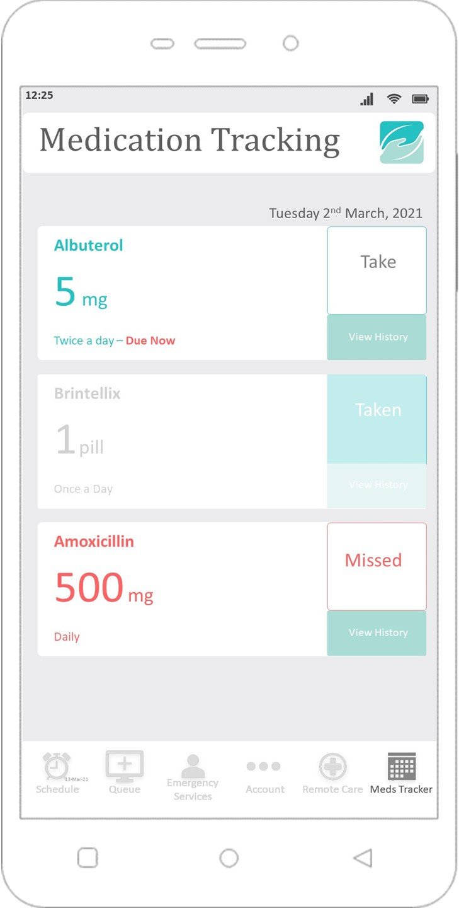

Block displaying a missed

medication.

Block displaying a

medication that is taken.

Block requesting user to

take medication.

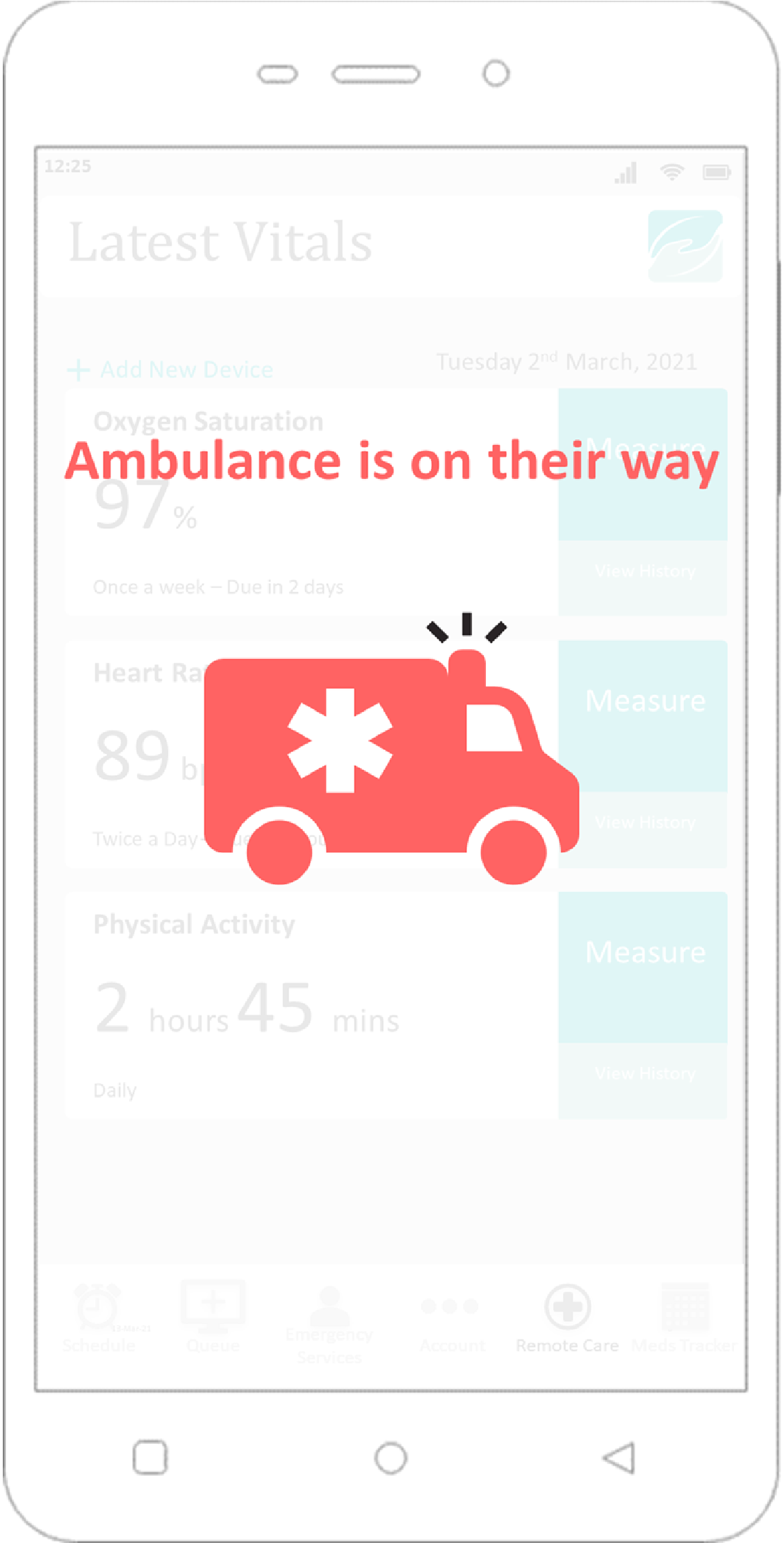

This is the emergency

sequence of the

application. If a doctor

detects a serious

anomaly, a distress signal

is sent to both an

ambulance, and the user.

Appendix C - Terminology:

**IoMT:** Internet of Medical Things (IoMT) refers to medical devices and software that uses IT integration, usually through a combination of wireless connectivity and cloud services to enhance medical services provided to the patient[ CITATION Mad20 \l 1033 ].

**Digital Biomarker:** health data (sleep, stress, heart rate, ECG, etc.) that is collected through

IoT devices such as smart watches and medical devices. [ CITATION The18 \l 1033 ]

**Geriatric:** relating to old people and their healthcare [ CITATION Dic21 \l 1033 ]

**Maintenance Medication:** type of medication taken on regular basis to stabilize chronic illnesses or their symptoms. Example includes depression, Attention deficit hyperactivity disorder (ADHD), and diabetes.

**References:**

Anees, S., 2017. *Rajje MV.* [Online] Available at: https://raajje.mv/6555

[Accessed 3 March 2021].

Anon., 2015. *Childnet International.* [Online]

Available at: https://www.childnet.com/blog/1-in-10-young-people-accidentally-spentmoney-on-in-app-purchases-survey-shows [Accessed 27 January 2021].

|  |  |  |  |  |  |
| --- | --- | --- | --- | --- | --- |
| Anon., 2017. |  | *Sun* |  | | *MV.* [Online] |
| Available  [Accessed 3 March 2021]. |  | at: |  |  | https://en.sun.mv/42563 |
| Anon., 2019. |  | *About* |  |  | *Us.* [Online] |
| Available  [Accessed 7 January 2021]. | at: |  |  |  | https://www.igmh.gov.mv/about-us/ |
| Anon., 2019. |  | *G1* |  |  | *Health.* [Online] |

Available at: https://www.g1.health/home/emergency-care/

[Accessed 10 March 2021].

Anon., 2020. *Northwell Health Patient Portal.* [Online]

Available at: https://www.northwell.edu/manage-your-care/patient-portal [Accessed 3 March 2021].

Anon., 2020. *Worldometer.* [Online]

Available at: https://www.worldometers.info/world-population/maldivespopulation/#:~:text=The%20median%20age%20in%20Maldives%20is%2029.9%20years.

[Accessed 27 Januray 2021].

Brigadoon Technology, n.d. *Robust IoT Applications for the Healthcare Industry.* [Online] Available at: https://www.brigadoontechnology.com/healthcare-business-intelligence/ [Accessed 8 March 2021].

|  |  |  |  |  |
| --- | --- | --- | --- | --- |
| Dictionary,com, n.d. | |  |  | *Geriatric.* [Online] |
| Available at:  [Accessed 7 March 2021]. |  |  |  | https://www.dictionary.com/browse/geriatric |
| Elliegrid, n.d. *ELLIE* |  | *-* |  | *SMART PILL BOX.* [Online] |
| Available at:  [Accessed 9 March 2021]. |  |  |  | https://elliegrid.com/products/ellie-smart-pill-box |
| Elliegrid, n.d. |  |  |  | *Home.* [Online] |
| Available  [Accessed 9 March 2021]. |  |  | at: | https://elliegrid.com/ |
| Foran, P., 2020. |  | *CTV* | | *News Toronto.* [Online] |

Available at: https://toronto.ctvnews.ca/halton-police-respond-to-about-300-cases-ofchildren-accidentally-calling-911-1.5163491 [Accessed 27 January 2021].

Futurist, T. M., 2018. *What Do Digital Biomarkers Mean?.* [Online] Available at: https://medicalfuturist.com/what-do-digital-biomarkers-mean/ [Accessed 7 March 2021].

Google Play, n.d. *Emergency Plus.* [Online]

Available at: https://play.google.com/store/apps/details?

id=com.threesixtyentertainment.nesn&hl=en_AU&gl=US [Accessed 12 03 2021].

Google, n.d. *How ELS computes location: Data flow and quality.* [Online] Available at: https://crisisresponse.google/emergencylocationservice/how-it-works/ [Accessed 10 03 2021].

Google, n.d. *How ELS computes location: Data flow and quality.* [Online] Available at: https://crisisresponse.google/emergencylocationservice/how-it-works/ [Accessed 12 03 2021].

Google, n.d. *Location quality.* [Online]

Available at: https://crisisresponse.google/emergencylocationservice/how-it-works/ [Accessed 10 03 2021].

hereiamapp, n.d. *SCENARIOS WHERE THE HERE I AM APP MAY BE APPLICABLE.*

[Online]

Available at: https://www.hereiamapp.com

[Accessed 10 03 2021].

Jangir, M., 2020. *IoMT Devices Will Revolutionize HealthTech in 2020.* [Online] Available at: https://www.rtinsights.com/iomt-devices-will-revolutionize-healthtech-in-2020/ [Accessed 9 March 2021].

Kakade, N., 2017. *Winning in implantable medical devices market: Pharma’s next frontier.*

[Online]

Available at: https://us.sganalytics.com/blog/winning-in-implantable-medical-devicesmarket-pharmas-next-frontier/ [Accessed 9 March 2021].

Karaoglu, K., 2020. *Remote patient monitoring for COVID-19; assess yourself.* [Online] Available at: https://vator.tv/news/2020-04-01-remote-patient-monitoring-for-covid-19assess-yourself

[Accessed 9 March 2021].

Ku, L., 2021. *11 Remote Patient Monitoring Companies You Should Know About.* [Online] Available at: https://www.plugandplaytechcenter.com/resources/10-remote-patientmonitoring-companies-you-should-know-about/ [Accessed 7 March 2021].

Nhslothian, n.d. *Emergency Departments (A&E).* [Online]

Available at: https://services.nhslothian.scot/Emergencies/EmergencyDepartmentsAE/Pages/default.aspx [Accessed 30 December 2020].

Ojigbo, S., 2016. *Internet of Things: Opportunities for the pharma and health care industries.* [Online]

Available at: https://pharmanewsonline.com/internet-of-things-opportunities-for-the-pharmaand-health-care-industries/ [Accessed 9 March 2021].

Pennell, J., 2015. *Today.* [Online]

Available at: https://www.today.com/money/why-we-cant-remember-phone-numbersanymore-t29986

[Accessed 26 January 2021].

Polowatch, 2021. *Polowatch.* [Online] Available at: https://polsowatch.com/

[Accessed 7 March 2021].

Rajapaksha, I., 2019. *Identity Federation-It’s all about Trust.* [Online]

Available at: https://blog.usejournal.com/identity-federation-its-all-about-trust-6a3608e82ca4 [Accessed 21 February 2021].

Robinson, M., 2019. *What Does Federated Login Mean? A Simple, Detailed Answer..*

[Online]

Available at: https://carvesystems.com/news/what-does-federated-login-mean-a-simpledetailed-answer/

[Accessed 12 February 2021].

Spitznagel, E., 2020. *New York Post.* [Online]

Available at: https://nypost.com/2020/01/25/generation-z-is-bigger-than-millennials-andtheyre-out-to-change-the-world/ [Accessed 26 January 2021].

The One Brief, n.d. *Wearing Your Data On Your Sleeve: The Promises And Pitfalls Of*

*Wearables.* [Online]

Available at: https://theonebrief.com/wearing-your-data-on-your-sleeve-the-promises-andpitfalls-of-wearables/

[Accessed 9 March 2021].

Vitls, n.d. *Vitls Technology.* [Online]

Available at: https://www.vitlsinc.com/vitls-technology

[Accessed 9 March 2021].